For the linear equation
6x + 5y − 60 = 0,
the x-intercept is  and the y-intercept is . The equation in slope-intercept form is
y =
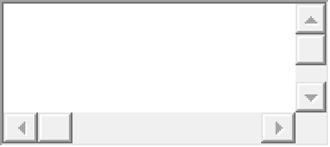

The slope of the graph of this equation is ………..

The slope of a horizontal line is  . The equation of the horizontal line passing through (6, 4) is

The slope of a vertical line is  . The equation of the vertical line passing through
(7, 5)
is

Find the slope of the line through P and Q.
P(19, −1), Q(8, −4)

Sketch a graph of the lines
y = −1
and
x = −1.

a) Sketch lines through (0, 0) with slopes
1, 0,
1
4
, 4, and −1.

Sketch lines through (0, 0) with slopes

1
3
,
1
2
, −
1
3
, and 3.

Find an equation for the line whose graph is sketched.

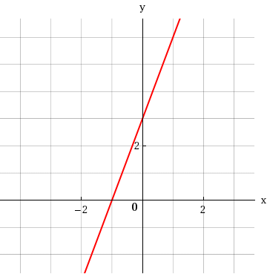

From the graphs of f and g in the figure, we find the following. (Assume that each point lies on the gridlines.)
(f + g)(−1) | = | 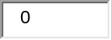
(f − g)(−1) | =
(fg)(−1) | =
(−1) | =
  f
  g
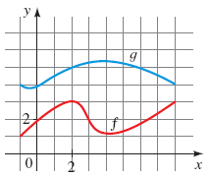


2.
[0/4 Points]DETAILSPREVIOUS ANSWERSSPRECALC7 2.7.001.ALT2.
MY NOTES
PRACTICE ANOTHER
From the graphs of f and g in the figure, we find the following. (Assume that each point lies on the gridlines.)
(f + g)(−2) | = | 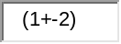
(f − g)(−2) | =
(fg)(−2) | =
(−2) | =
  f
  g
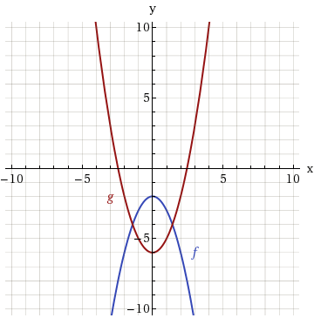


3.
[–/4 Points]DETAILSSPRECALC7 2.7.001.ALT.
MY NOTES
PRACTICE ANOTHER
From the graphs of f and g in the figure, we find the following. (Assume that each point lies on the gridlines.)
(f + g)(6) | =
(f − g)(6) | =
(fg)(6) | =
(6) | =
  f
  g
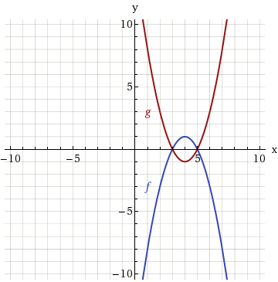

4.
[–/2 Points]DETAILSSPRECALC7 2.7.002.
MY NOTES
PRACTICE ANOTHER
By definition, (f ∘ g)(x) =  . So if g(8) = 12 and f(12) = 16, then (f ∘ g)(8) = .

5.
[–/2 Points]DETAILSSPRECALC7 2.7.003.
MY NOTES
PRACTICE ANOTHER
If the rule of the function f is "add three" and the rule of the function g is "multiply by 7," then the rule of
f ∘ g is "  ," and the rule of g ∘ f is " ."

6.
[–/4 Points]DETAILSSPRECALC7 2.7.004.
MY NOTES
PRACTICE ANOTHER
Suppose the rule of the function f is "add one" and the rule of the function g is "multiply by 6."
How can we express these functions algebraically?
f(x) | =
g(x) | =
(f ∘ g)(x) | =
(g ∘ f)(x) | =

7.
[–/4 Points]DETAILSSPRECALC7 2.7.005.
MY NOTES
Let f and g be functions.
(a) The function
(f + g)(x)
is defined for all values of x that are in the domain(s) of  .
(b) The function
(fg)(x)
is defined for all values of x that are in the domain(s) of .
(c) The function
(f/g)(x)
is defined for all values of x that are in the domain(s) of , and
g(x)
is not equal to .

8.
[–/2 Points]DETAILSSPRECALC7 2.7.006.
MY NOTES
Let f and g be functions.
The composition
(f ∘ g)(x)
is defined for all values of x for which x is in the domain of  and
g(x)
is in the domain of .

9.
[–/8 Points]DETAILSSPRECALC7 2.7.007.
MY NOTES
PRACTICE ANOTHER
Find
f + g,

f − g,

fg,
and
f/g
and their domains.
f(x) = x, g(x) = 5x
Find
(f + g)(x).

Find the domain of
(f + g)(x).
(Enter your answer using interval notation.)

Find
(f − g)(x).

Find the domain of
(f − g)(x).
(Enter your answer using interval notation.)

Find
(fg)(x).

Find the domain of
(fg)(x).
(Enter your answer using interval notation.)

Find

f
g

(x).

Find the domain of

f
g

(x).
(Enter your answer using interval notation.)

10.
[–/8 Points]DETAILSSPRECALC7 2.7.008.
MY NOTES
Find
f + g,

f − g,

fg,
and
f/g
and their domains.
f(x) = x, g(x) =
x
Find
(f + g)(x).

Find the domain of
(f + g)(x).
(Enter your answer using interval notation.)

Find
(f − g)(x).

Find the domain of
(f − g)(x).
(Enter your answer using interval notation.)

Find
(fg)(x).

Find the domain of
(fg)(x).
(Enter your answer using interval notation.)

Find

f
g

(x).

Find the domain of

f
g

(x).
(Enter your answer using interval notation.)

11.
[–/8 Points]DETAILSSPRECALC7 2.7.009.
MY NOTES
Find
f + g,

f − g,

fg,
and
f/g
and their domains.
f(x) = x² + x, g(x) = x²
Find
(f + g)(x).

Find the domain of
(f + g)(x).
(Enter your answer using interval notation.)

Find
(f − g)(x).

Find the domain of
(f − g)(x).
(Enter your answer using interval notation.)

Find
(fg)(x).

Find the domain of
(fg)(x).
(Enter your answer using interval notation.)

Find

f
g

(x).

Find the domain of

f
g

(x).
(Enter your answer using interval notation.)

12.
[–/8 Points]DETAILSSPRECALC7 2.7.010.
MY NOTES
PRACTICE ANOTHER
Find
f + g,

f − g,

fg,
and
f/g
and their domains.
f(x) = 3 − x², g(x) = x² − 4
Find
(f + g)(x).

Find the domain of
(f + g)(x).
(Enter your answer using interval notation.)

Find
(f − g)(x).

Find the domain of
(f − g)(x).
(Enter your answer using interval notation.)

Find
(fg)(x).

Find the domain of
(fg)(x).
(Enter your answer using interval notation.)

Find

f
g

(x).

Find the domain of

f
g

(x).
(Enter your answer using interval notation.)

13.
[–/8 Points]DETAILSSPRECALC7 2.7.011.
MY NOTES
PRACTICE ANOTHER
Find
f + g,

f − g,

fg,
and
f/g
and their domains.
f(x) = 5 − x, g(x) = x² − 3x
Find
(f + g)(x).

Find the domain of
(f + g)(x).
(Enter your answer using interval notation.)

Find
(f − g)(x).

Find the domain of
(f − g)(x).
(Enter your answer using interval notation.)

Find
(fg)(x).

Find the domain of
(fg)(x).
(Enter your answer using interval notation.)

Find

f
g

(x).

Find the domain of

f
g

(x).
(Enter your answer using interval notation.)

14.
[–/8 Points]DETAILSSPRECALC7 2.7.012.
MY NOTES
PRACTICE ANOTHER
Consider the following functions.
f(x) = x² + 2x, g(x) = 3x² − 1
Find
(f + g)(x).

Find the domain of
(f + g)(x).
(Enter your answer using interval notation.)

Find
(f − g)(x).

Find the domain of
(f − g)(x).
(Enter your answer using interval notation.)

Find
(fg)(x).

Find the domain of
(fg)(x).
(Enter your answer using interval notation.)

Find

f
g

(x).

Find the domain of

f
g

(x).
(Enter your answer using interval notation.)

15.
[–/8 Points]DETAILSSPRECALC7 2.7.013.
MY NOTES
PRACTICE ANOTHER
Find
f + g,

f − g,

fg,
and
f/g
and their domains.
f(x) =
25 − x²
, g(x) =
x + 3
Find
(f + g)(x).

Find the domain of
(f + g)(x).
(Enter your answer using interval notation.)

Find
(f − g)(x).

Find the domain of
(f − g)(x).
(Enter your answer using interval notation.)

Find
(fg)(x).

Find the domain of
(fg)(x).
(Enter your answer using interval notation.)

Find

f
g

(x).

Find the domain of

f
g

(x).
(Enter your answer using interval notation.)

SPRECALC7 2.8.002.
MY NOTES
(a) For a function to have an inverse, it must be . So which one of the following functions has an inverse?

g(x) = x³
f(x) = x²

(b) What is the inverse of the function that you chose in part (a)?
y =

2.
[–/5 Points]DETAILSSPRECALC7 2.8.003.
MY NOTES
PRACTICE ANOTHER
A function f has the following verbal description: "Multiply by 3, add 7, and then take the third power of the result."
(a) Write a verbal description for
f ⁻¹.
"Take the root, 7, then 3."
(b) Find algebraic formulas that express f and
f ⁻¹
in terms of the input x.
f(x) | =
f ⁻¹(x) | =

3.
[–/3 Points]DETAILSSPRECALC7 2.8.004.
MY NOTES
PRACTICE ANOTHER
A graph of a function f is given.
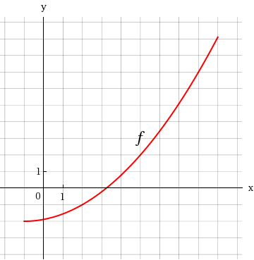
Does f have an inverse?
YesNo
If so, find the following. (If an answer does not exist, enter DNE.)
f ⁻¹(2) | =
f ⁻¹(7) | =

4.
[–/1 Points]DETAILSSPRECALC7 2.8.005.
MY NOTES
PRACTICE ANOTHER
If the point
(4, 3)
is on the graph of the function f, then the point
(x, y) =

is on the graph of
f ⁻¹.

5.
[–/2 Points]DETAILSSPRECALC7 2.8.006.
MY NOTES
True or false?
(a) If f has an inverse, then
f ⁻¹(x)
is always the same as
1
f(x)
.

TrueFalse
(b) If f has an inverse, then
f ⁻¹(f(x)) = x.

TrueFalse

6.
[–/1 Points]DETAILSSPRECALC7 2.8.007.
MY NOTES
PRACTICE ANOTHER
A graph of a function f is given.
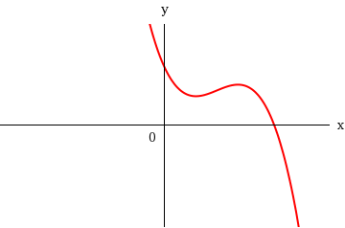
Determine whether f is one-to-one.
Yes, f is one-to-one.No, f is not one-to-one.

7.
[–/1 Points]DETAILSSPRECALC7 2.8.008.
MY NOTES
PRACTICE ANOTHER
A graph of a function f is given.
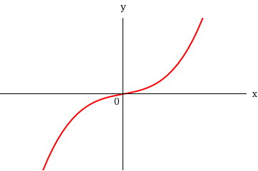
Determine whether f is one-to-one.
Yes, f is one-to-one.No, f is not one-to-one.

8.
[–/1 Points]DETAILSSPRECALC7 2.8.009.
MY NOTES
PRACTICE ANOTHER
A graph of a function f is given.
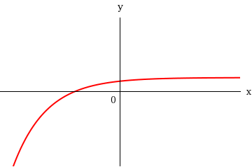
Determine whether f is one-to-one.
Yes, f is one-to-one.No, f is not one-to-one.

9.
[–/1 Points]DETAILSSPRECALC7 2.8.010.
MY NOTES
PRACTICE ANOTHER
A graph of a function f is given.
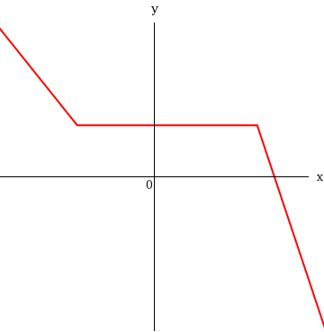
Determine whether f is one-to-one.
Yes, f is one-to-one.No, f is not one-to-one.

10.
[–/1 Points]DETAILSSPRECALC7 2.8.014.
MY NOTES
PRACTICE ANOTHER
Determine whether the function is one-to-one.
f(x) = 6x − 9
is one-to-oneis not one-to-one

11.
[–/1 Points]DETAILSSPRECALC7 2.8.016.
MY NOTES
PRACTICE ANOTHER
Determine whether the function is one-to-one.
f(x) = |2x|
is one-to-oneis not one-to-one

12.
[–/3 Points]DETAILSSPRECALC7 2.8.029.
MY NOTES
PRACTICE ANOTHER
A graph of a function is given. Use the graph to find the indicated values.
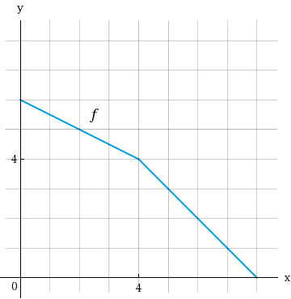
(a)
f ⁻¹(1)
(b)
f ⁻¹(4)
(c)
f ⁻¹(6)

13.
[–/3 Points]DETAILSSPRECALC7 2.8.030.
MY NOTES
PRACTICE ANOTHER
A graph of a function is given. Use the graph to find the indicated values.
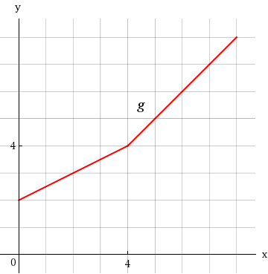
(a)
g⁻¹(3)
(b)
g⁻¹(4)
(c)
g⁻¹(7)

14.
[–/1 Points]DETAILSSPRECALC7 2.8.039.
MY NOTES
PRACTICE ANOTHER
Use the Inverse Function Property to determine whether f and g are inverses of each other.
f(x) = 6x + 8; g(x) =
x − 8
6
f and g are inverses of each other.f and g are not inverses of each other.

15.
[–/1 Points]DETAILSSPRECALC7 2.8.040.MI.ALT.
MY NOTES
PRACTICE ANOTHER
Determine whether f and g are inverses of each other.
f(x) = 6 − 4x; g(x) =
6 − x
4

f and g are inverses of each other.f and g are not inverses of each other.

16.
[–/1 Points]DETAILSSPRECALC7 2.8.049.
MY NOTES
PRACTICE ANOTHER
Find the inverse function of f.
f(x) = 4x + 6
f ⁻¹(x) =

17.
[–/1 Points]DETAILSSPRECALC7 2.8.050.MI.
MY NOTES
PRACTICE ANOTHER
Find the inverse function of f.
f(x) = 2 − 6x
f ⁻¹(x) =

18.
[–/1 Points]DETAILSSPRECALC7 2.8.051.
MY NOTES
PRACTICE ANOTHER
Find the inverse function of f.
f(x) = 4 − 2x³
f ⁻¹(x) =

19.
[–/1 Points]DETAILSSPRECALC7 2.8.052.
MY NOTES
PRACTICE ANOTHER
Find the inverse function of f.
f(x) = 5x³ + 9
f ⁻¹(x) =

20.
[–/1 Points]DETAILSSPRECALC7 2.8.053.MI.
MY NOTES
PRACTICE ANOTHER
Find the inverse function of f.
f(x) =
1
x + 3
f ⁻¹(x) =

1.
[–/3 Points]DETAILSSPRECALC7 2.8.002.
MY NOTES
(a) For a function to have an inverse, it must be . So which one of the following functions has an inverse?
g(x) = x³
f(x) = x²

(b) What is the inverse of the function that you chose in part (a)?
y =

2.
[–/5 Points]DETAILSSPRECALC7 2.8.003.
MY NOTES
PRACTICE ANOTHER
A function f has the following verbal description: "Multiply by 3, add 7, and then take the third power of the result."
(a) Write a verbal description for
f ⁻¹.
"Take the root, 7, then 3."
(b) Find algebraic formulas that express f and
f ⁻¹
in terms of the input x.
f(x) | =
f ⁻¹(x) | =

3.
[–/3 Points]DETAILSSPRECALC7 2.8.004.
MY NOTES
PRACTICE ANOTHER
A graph of a function f is given.
Does f have an inverse?
YesNo
If so, find the following. (If an answer does not exist, enter DNE.)
f ⁻¹(2) | =
f ⁻¹(7) | =

4.
[–/1 Points]DETAILSSPRECALC7 2.8.005.
MY NOTES
PRACTICE ANOTHER
If the point
(4, 3)
is on the graph of the function f, then the point
(x, y) =

is on the graph of
f ⁻¹.

5.
[–/2 Points]DETAILSSPRECALC7 2.8.006.
MY NOTES
True or false?
(a) If f has an inverse, then
f ⁻¹(x)
is always the same as
1
f(x)
.

TrueFalse
(b) If f has an inverse, then
f ⁻¹(f(x)) = x.

TrueFalse

6.
[–/1 Points]DETAILSSPRECALC7 2.8.007.
MY NOTES
PRACTICE ANOTHER
A graph of a function f is given.
Determine whether f is one-to-one.
Yes, f is one-to-one.No, f is not one-to-one.

7.
[–/1 Points]DETAILSSPRECALC7 2.8.008.
MY NOTES
PRACTICE ANOTHER
A graph of a function f is given.
Determine whether f is one-to-one.
Yes, f is one-to-one.No, f is not one-to-one.

8.
[–/1 Points]DETAILSSPRECALC7 2.8.009.
MY NOTES
PRACTICE ANOTHER
A graph of a function f is given.
Determine whether f is one-to-one.
Yes, f is one-to-one.No, f is not one-to-one.

9.
[–/1 Points]DETAILSSPRECALC7 2.8.010.
MY NOTES
PRACTICE ANOTHER
A graph of a function f is given.
Determine whether f is one-to-one.
Yes, f is one-to-one.No, f is not one-to-one.

10.
[–/1 Points]DETAILSSPRECALC7 2.8.014.
MY NOTES
PRACTICE ANOTHER
Determine whether the function is one-to-one.
f(x) = 6x − 9
is one-to-oneis not one-to-one

11.
[–/1 Points]DETAILSSPRECALC7 2.8.016.
MY NOTES
PRACTICE ANOTHER
Determine whether the function is one-to-one.
f(x) = |2x|
is one-to-oneis not one-to-one

12.
[–/3 Points]DETAILSSPRECALC7 2.8.029.
MY NOTES
PRACTICE ANOTHER
A graph of a function is given. Use the graph to find the indicated values.
(a)
f ⁻¹(1)
(b)
f ⁻¹(4)
(c)
f ⁻¹(6)

13.
[–/3 Points]DETAILSSPRECALC7 2.8.030.
MY NOTES
PRACTICE ANOTHER
A graph of a function is given. Use the graph to find the indicated values.
(a)
g⁻¹(3)
(b)
g⁻¹(4)
(c)
g⁻¹(7)

14.
[–/1 Points]DETAILSSPRECALC7 2.8.039.
MY NOTES
PRACTICE ANOTHER
Use the Inverse Function Property to determine whether f and g are inverses of each other.
f(x) = 6x + 8; g(x) =
x − 8
6
f and g are inverses of each other.f and g are not inverses of each other.

15.
[–/1 Points]DETAILSSPRECALC7 2.8.040.MI.ALT.
MY NOTES
PRACTICE ANOTHER
Determine whether f and g are inverses of each other.
f(x) = 6 − 4x; g(x) =
6 − x
4

f and g are inverses of each other.f and g are not inverses of each other.

16.
[–/1 Points]DETAILSSPRECALC7 2.8.049.
MY NOTES
PRACTICE ANOTHER
Find the inverse function of f.
f(x) = 4x + 6
f ⁻¹(x) =

17.
[–/1 Points]DETAILSSPRECALC7 2.8.050.MI.
MY NOTES
PRACTICE ANOTHER
Find the inverse function of f.
f(x) = 2 − 6x
f ⁻¹(x) =

18.
[–/1 Points]DETAILSSPRECALC7 2.8.051.
MY NOTES
PRACTICE ANOTHER
Find the inverse function of f.
f(x) = 4 − 2x³
f ⁻¹(x) =

19.
[–/1 Points]DETAILSSPRECALC7 2.8.052.
MY NOTES
PRACTICE ANOTHER
Find the inverse function of f.
f(x) = 5x³ + 9
f ⁻¹(x) =

20.
[–/1 Points]DETAILSSPRECALC7 2.8.053.MI.
MY NOTES
PRACTICE ANOTHER
Find the inverse function of f.
f(x) =
1
x + 3
f ⁻¹(x) =

PRACTICE ANOTHER
The graph of
f(x) = 4(x − 1)² − 2
is a parabola that opens , with its vertex at
(x, y) =

,
and
f(1) =
is the value of f.

2.
[–/4 Points]DETAILSSPRECALC7 3.1.004.
MY NOTES
PRACTICE ANOTHER
The graph of
f(x) = −9(x − 2)² − 3
is a parabola that opens , with its vertex at
(x, y) =

,
and
f(2) =
is the value of f.

3.
[–/8 Points]DETAILSSPRECALC7 3.1.005.
MY NOTES
PRACTICE ANOTHER
The graph of a quadratic function f is given.
f(x) = −x² + 6x − 5
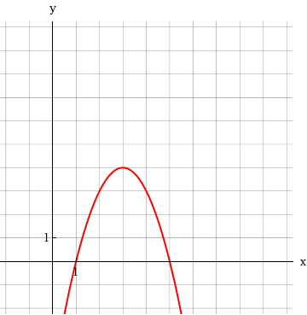
(a) Find the coordinates of the vertex and the x- and y-intercepts.
vertex |  | (x, y) | =
x-intercepts |  | (x, y) | = | (smaller x-value)
 |  | (x, y) | = | (larger x-value)
y-intercept |  | (x, y) | =
(b) Find the maximum or minimum value of f.
The value of f is f(x) = .
(c) Find the domain and range of f. (Enter your answers using interval notation.)
domain
range

4.
[–/8 Points]DETAILSSPRECALC7 3.1.006.MI.
MY NOTES
PRACTICE ANOTHER
The graph of a quadratic function f is given.
f(x) = −
1
2
x² − 2x + 6
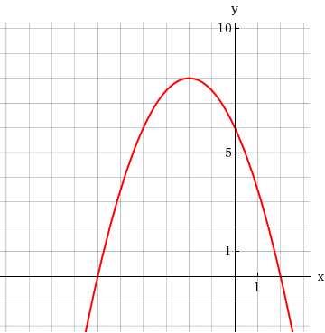
(a) Find the coordinates of the vertex and the x- and y-intercepts.
vertex |  | (x, y) | =
x-intercepts |  | (x, y) | = | (smaller x-value)
 |  | (x, y) | = | (larger x-value)
y-intercept |  | (x, y) | =
(b) Find the maximum or minimum value of f.
The value of f is f(x) = .
(c) Find the domain and range of f. (Enter your answers using interval notation.)
domain
range

5.
[–/8 Points]DETAILSSPRECALC7 3.1.007.
MY NOTES
PRACTICE ANOTHER
The graph of a quadratic function f is given.
f(x) = 3x² − 6x − 3
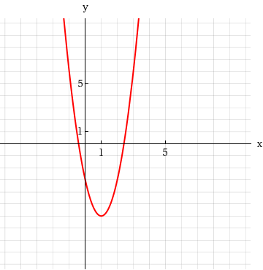
(a) Find the coordinates of the vertex and the x- and y-intercepts. (Round your answers to one decimal place.)
vertex |  | (x, y) | =
x-intercepts |  | (x, y) | = | (smaller x-value)
 |  | (x, y) | = | (larger x-value)
y-intercept |  | (x, y) | =
(b) Find the maximum or minimum value of f.
The value of f is f(x) = .
(c) Find the domain and range of f. (Enter your answers using interval notation.)
domain
range

6.
[–/8 Points]DETAILSSPRECALC7 3.1.008.
MY NOTES
PRACTICE ANOTHER
The graph of a quadratic function f is given.
f(x) = 2x² + 4x − 3
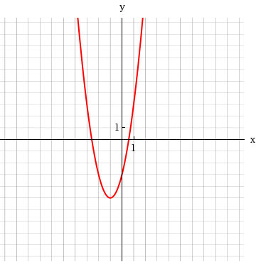
(a) Find the coordinates of the vertex and the x- and y-intercepts. (Round your answers to one decimal place.)
vertex |  | (x, y) | =
x-intercepts |  | (x, y) | = | (smaller x-value)
 |  | (x, y) | = | (larger x-value)
y-intercept |  | (x, y) | =
(b) Find the maximum or minimum value of f.
The value of f is f(x) = .
(c) Find the domain and range of f. (Enter your answers using interval notation.)
domain
range

7.
[–/7 Points]DETAILSSPRECALC7 3.1.009.ALT.
MY NOTES
PRACTICE ANOTHER
A quadratic function f is given.
f(x) = x² − 2x + 5
(a) Express f in transformation form.
f(x) | =
(b) Find the vertex and x- and y-intercepts of f. (If an answer does not exist, enter DNE.)
vertex | (x, y) | =
x-intercept | (x, y) | =
y-intercept | (x, y) | =
(c) Sketch a graph of f.
Selection Tool
Line
Ray
Segment
Circle
Vertical Parabola
Horizontal Parabola
Point
No Solution
Help
-10
-9
-8
-7
-6
-5
-4
-3
-2
-1
1
2
3
4
5
6
7
8
9
10
-10
-9
-8
-7
-6
-5
-4
-3
-2
-1
1
2
3
4
5
6
7
8
9
10
Clear Graph
Delete Layer
Fill

WebAssign Graphing Tool

Graph LayersToggle Open/Closed
- After you add an object to the graph you can use Graph Layers to view and edit its properties.
(d) Find the domain and range of f. (Enter your answers using interval notation.)
domain
range

8.
[–/8 Points]DETAILSSPRECALC7 3.1.010.
MY NOTES
PRACTICE ANOTHER
A quadratic function f is given.
f(x) = x² + 4x − 3
(a) Express f in standard form.
f(x) | =
(b) Find the vertex and x- and y-intercepts of f. (If an answer does not exist, enter DNE.)
vertex | (x, y) | =
x-intercepts | (x, y) | = | (smaller x-value)
 | (x, y) | = | (larger x-value)
y-intercept | (x, y) | =
(c) Sketch a graph of f.
Selection Tool
Line
Ray
Segment
Circle
Vertical Parabola
Horizontal Parabola
Point
No Solution
Help
-10
-9
-8
-7
-6
-5
-4
-3
-2
-1
1
2
3
4
5
6
7
8
9
10
-15
-14
-13
-12
-11
-10
-9
-8
-7
-6
-5
-4
-3
-2
-1
1
2
3
4
5
Clear Graph
Delete Layer
Fill

WebAssign Graphing Tool

Graph LayersToggle Open/Closed
- After you add an object to the graph you can use Graph Layers to view and edit its properties.
(d) Find the domain and range of f. (Enter your answers using interval notation.)
domain
range

9.
[–/8 Points]DETAILSSPRECALC7 3.1.010.ALT.
MY NOTES
PRACTICE ANOTHER
A quadratic function f is given.
f(x) = x² + 4x − 1
(a) Express f in transformation form.
f(x) | =
(b) Find the vertex and x- and y-intercepts of f. (Round your answers to two decimal places. If an answer does not exist, enter DNE.)
vertex | (x, y) | =
x-intercepts | (x, y) | = | (smaller x-value)
 | (x, y) | = | (larger x-value)
y-intercept | (x, y) | =
(c) Sketch a graph of f.

(d) Find the domain and range of f. (Enter your answers using interval notation.)
domain
range

10.
[–/8 Points]DETAILSSPRECALC7 3.1.011.
MY NOTES
PRACTICE ANOTHER
A quadratic function f is given.
f(x) = x² − 4x
(a) Express f in standard form.
f(x) | =
(b) Find the vertex and x- and y-intercepts of f. (If an answer does not exist, enter DNE.)
vertex | (x, y) | =
x-intercepts | (x, y) | = | (smaller x-value)
 | (x, y) | = | (larger x-value)
y-intercept | (x, y) | =
(c) Sketch a graph of f.

WebAssign Graphing Tool

Graph LayersToggle Open/Closed
- After you add an object to the graph you can use Graph Layers to view and edit its properties.
(d) Find the domain and range of f. (Enter your answers using interval notation.)
domain
range

MY NOTES
Only one of the following graphs could be the graph of a polynomial function. Which one? Why are the others not graphs of polynomials? (Select all that apply.)
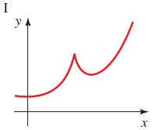
The graph could be that of a polynomial function.The graph could not be that of a polynomial function because it has a cusp.The graph could not be that of a polynomial function because it has a break.The graph could not be that of a polynomial function because it does not pass the horizontal line test.The graph could not be that of a polynomial function because it is not smooth.

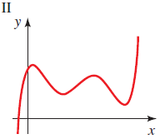
The graph could be that of a polynomial function.The graph could not be that of a polynomial function because it has a cusp.The graph could not be that of a polynomial function because it has a break.The graph could not be that of a polynomial function because it does not pass the horizontal line test.The graph could not be that of a polynomial function because it is not smooth.

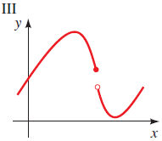
The graph could be that of a polynomial function.The graph could not be that of a polynomial function because it has a cusp.The graph could not be that of a polynomial function because it has a break.The graph could not be that of a polynomial function because it does not pass the horizontal line test.The graph could not be that of a polynomial function because it is not smooth.

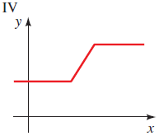
The graph could be that of a polynomial function.The graph could not be that of a polynomial function because it has a cusp.The graph could not be that of a polynomial function because it has a break.The graph could not be that of a polynomial function because it does not pass the horizontal line test.The graph could not be that of a polynomial function because it is not smooth.

2.
[–/4 Points]DETAILSSPRECALC7 3.2.002.
MY NOTES
PRACTICE ANOTHER
Describe the end behavior of each polynomial.
(a)
y = x³ − 2x² + 8x − 19

End behavior: | y → |  | as x → ∞
 | y → |  | as x → −∞
(b)
y = −8x⁴ + 16x + 800

End behavior: | y → |  | as x → ∞
 | y → |  | as x → −∞

3.
[–/3 Points]DETAILSSPRECALC7 3.2.003.
MY NOTES
If c is a zero of the polynomial P, then consider the following.
(a)
P(c) =  .
(b)
x − c is a of P(x).
(c)
c is a(n) -intercept of the graph of P.

4.
[–/4 Points]DETAILSSPRECALC7 3.2.005.
MY NOTES
PRACTICE ANOTHER
Sketch the graph of each function by transforming the graph of an appropriate function of the form
y = x^{n}
from the graphs below.
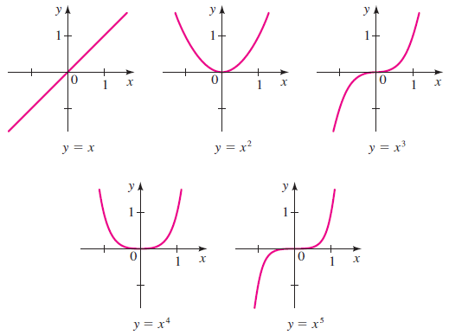
(a)
P(x) = x² − 4
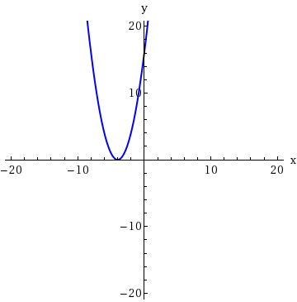 | 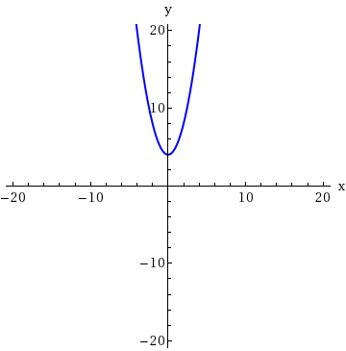
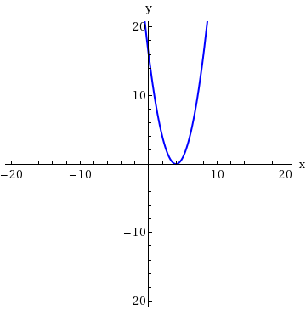 | 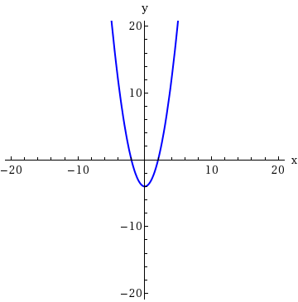
(b)
Q(x) = (x − 4)²
(c)
P(x) = 3x² + 2
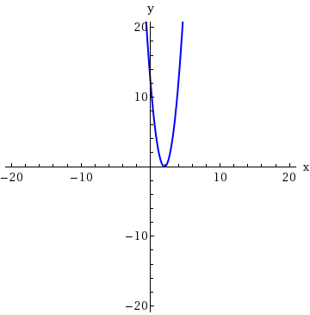 | 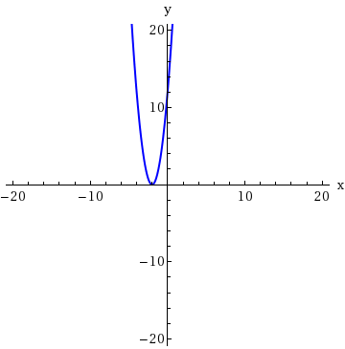
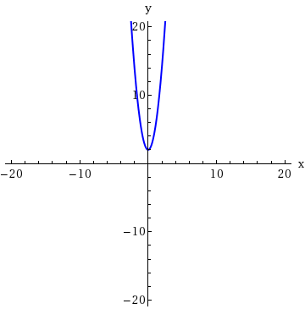 | 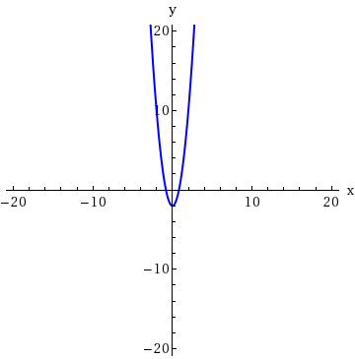
(d)
P(x) = −(x + 2)²
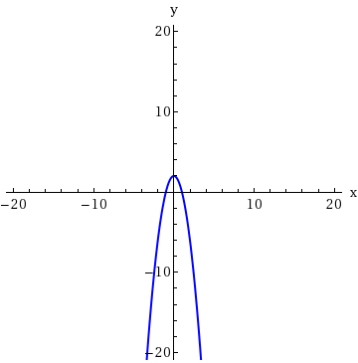 | 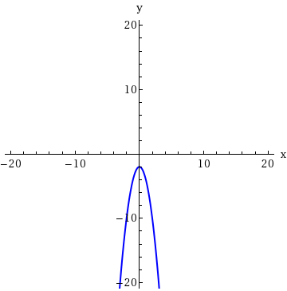
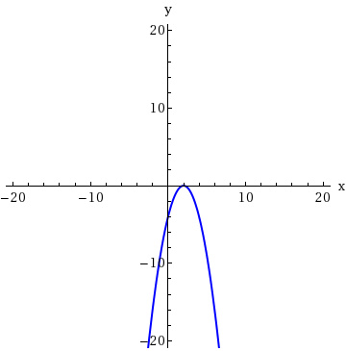 | 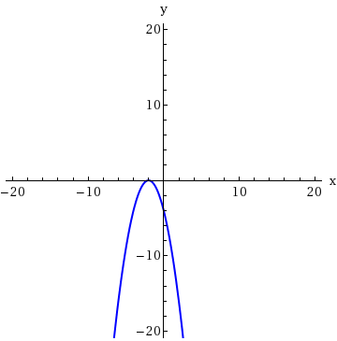

5.
[–/4 Points]DETAILSSPRECALC7 3.2.006.
MY NOTES
PRACTICE ANOTHER
Sketch the graph of each function by transforming the graph of an appropriate function of the form
y = x^{n}
from the graphs below.
(a)
P(x) = x⁴ − 81
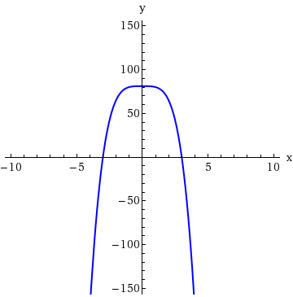 | 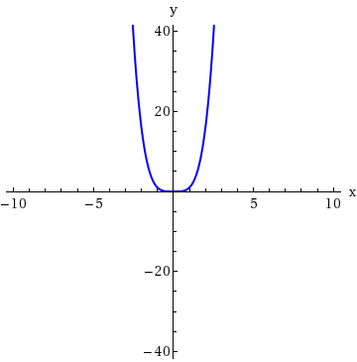
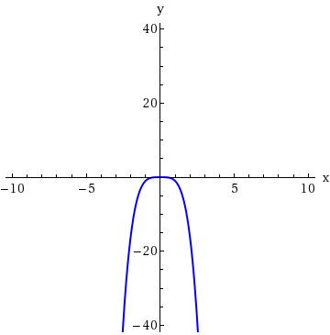 | 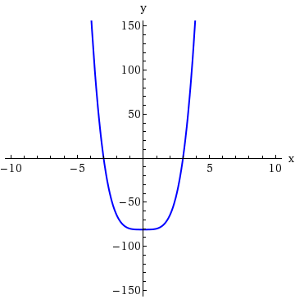
(b)
P(x) = −(x + 4)⁴
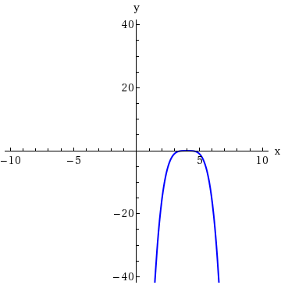 | 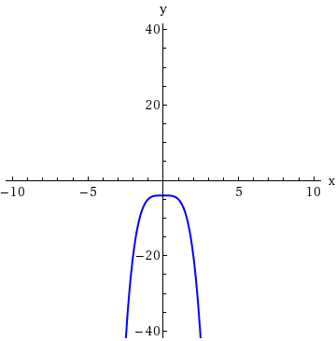
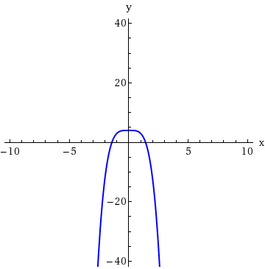 | 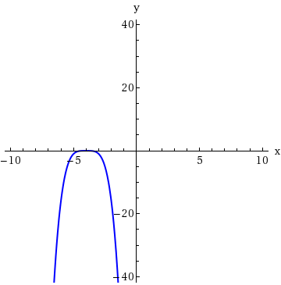
(c)
P(x) = −4x⁴ + 4
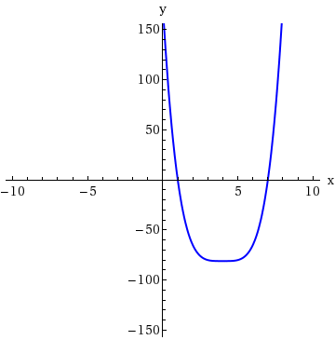 | 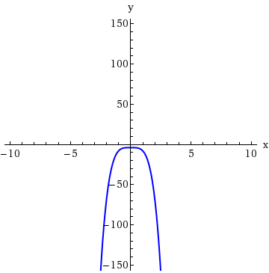
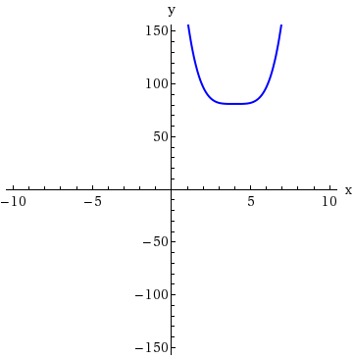 | 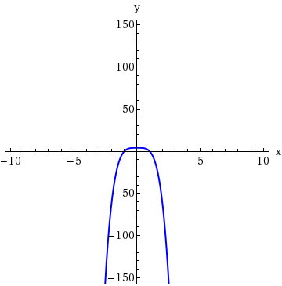
(d)
P(x) = (x − 4)⁴
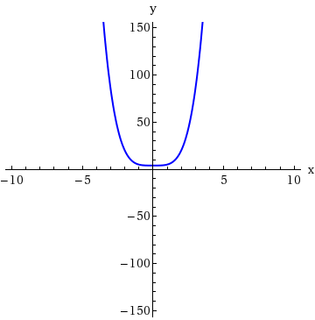 | 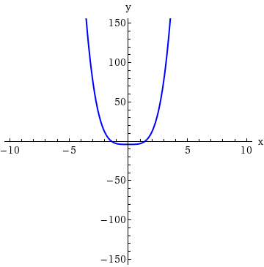
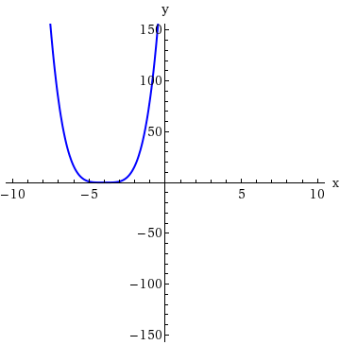 | 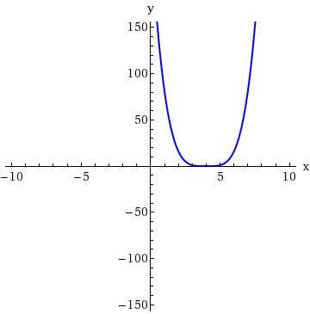

6.
[–/4 Points]DETAILSSPRECALC7 3.2.007.
MY NOTES
PRACTICE ANOTHER
Sketch the graph of each function by transforming the graph of an appropriate function of the form
y = x^{n}
from the graphs below.
(a)
P(x) = x³ − 8
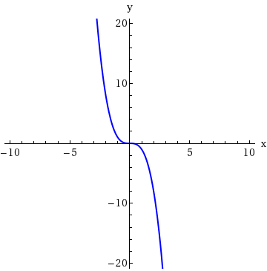 | 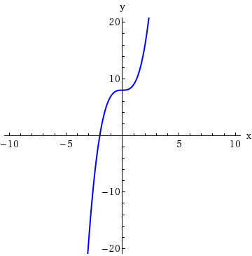
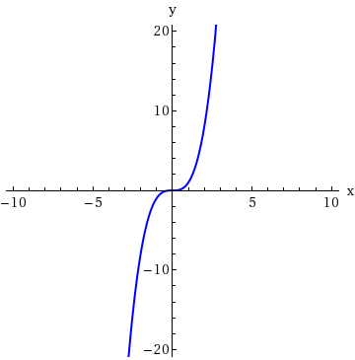 | 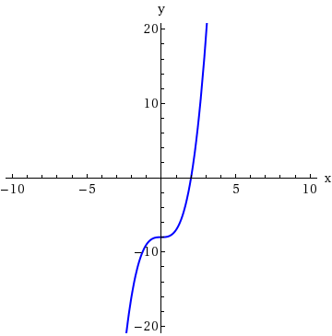
(b)
Q(x) = −x³ + 27
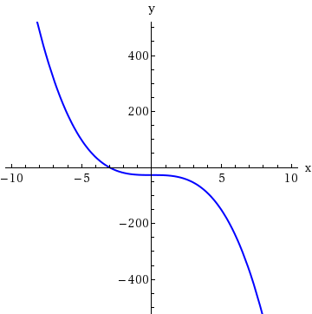 | 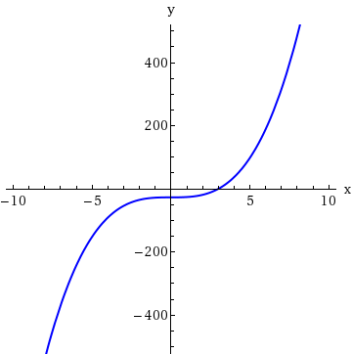
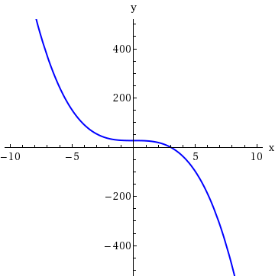 | 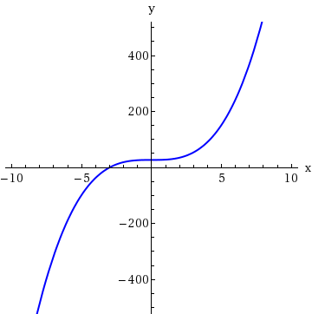
(c)
R(x) = −(x + 2)³
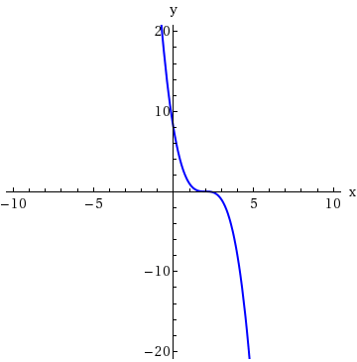 | 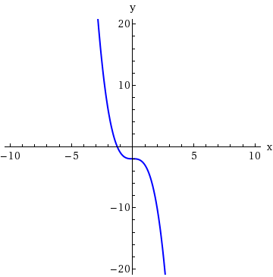
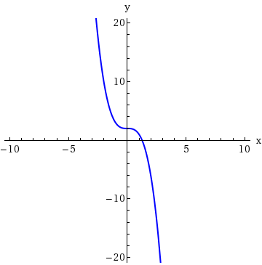 | 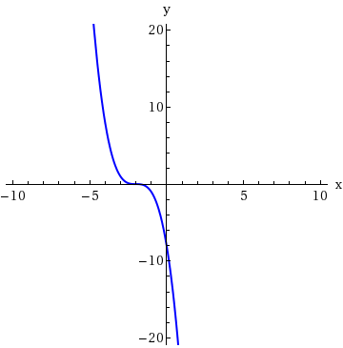
(d)
S(x) =
1
2
(x − 1)³ + 1
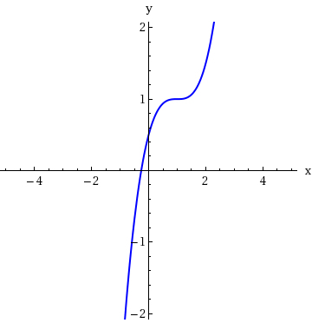 | 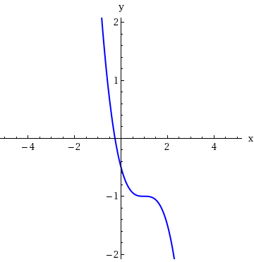
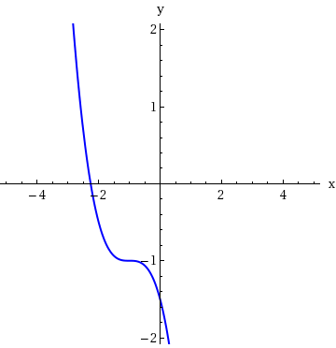 | 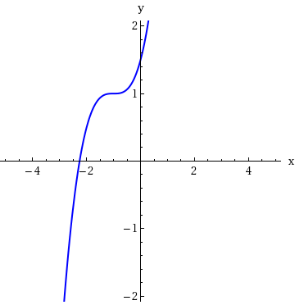

7.
[–/3 Points]DETAILSSPRECALC7 3.2.009.
MY NOTES
PRACTICE ANOTHER
A polynomial function is given.
P(x) = x(x² − 9)
(a) Describe the end behavior of the polynomial function.
End behavior: | y → |  | as x → ∞
 | y → |  | as x → −∞
(b) Match the polynomial function with one of the following graphs.
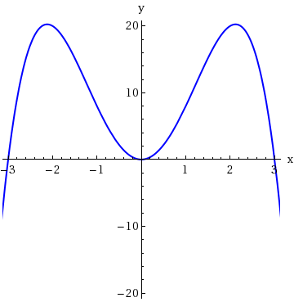 | 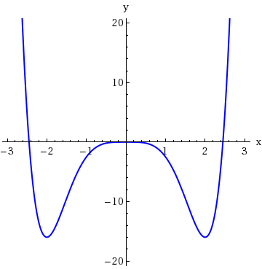
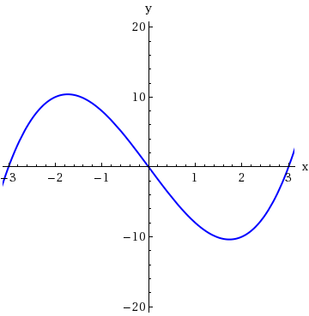 | 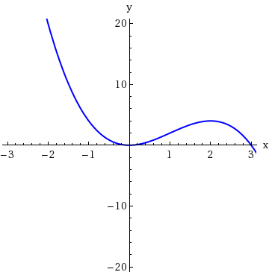
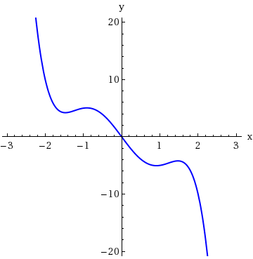 | 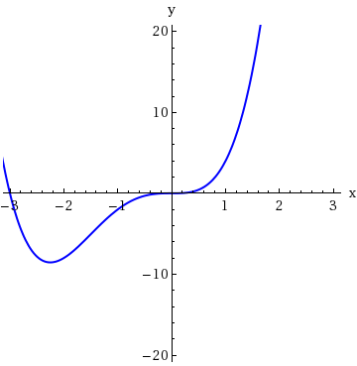

8.
[–/4 Points]DETAILSSPRECALC7 3.2.008.
MY NOTES
PRACTICE ANOTHER
Sketch the graph of each function by transforming the graph of an appropriate function of the form
y = x^{n}
from the graphs below.
(a)
P(x) = (x + 4)⁵
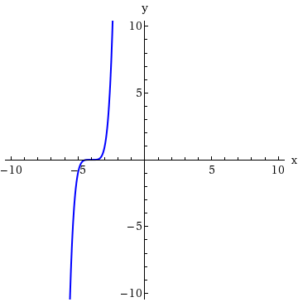 | 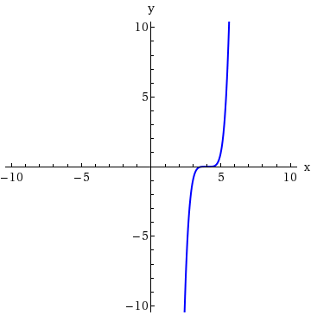
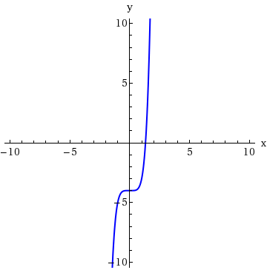 | 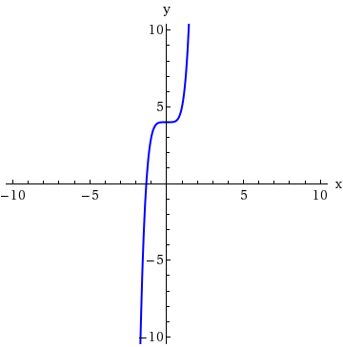
(b)
Q(x) = 2(x + 3)⁵ − 64
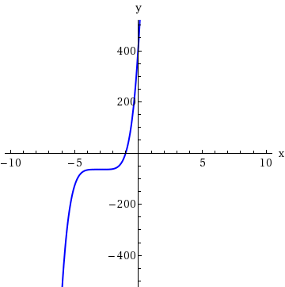 | 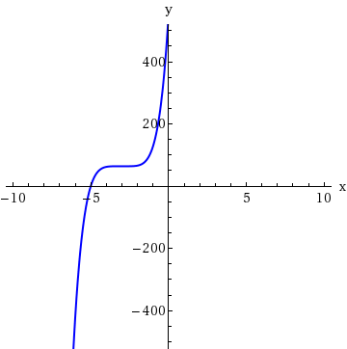
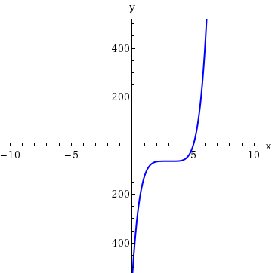 | 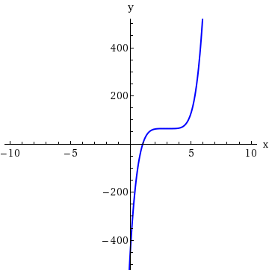
(c)
R(x) = −
1
2
(x − 2)⁵
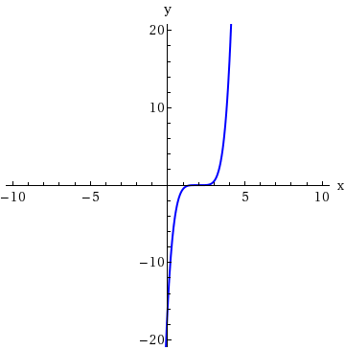 | 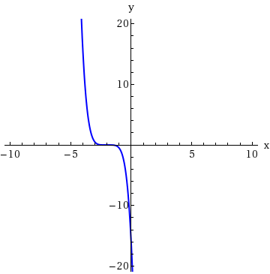
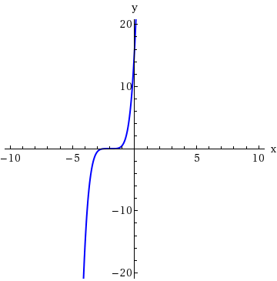 | 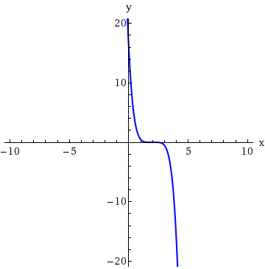
(d)
S(x) = −
1
2
(x − 2)⁵ + 36
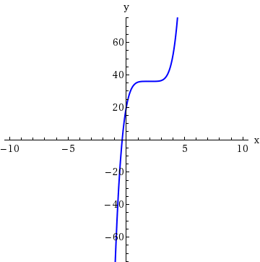 | 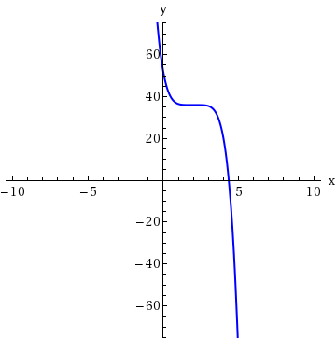
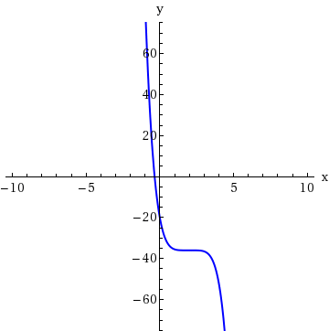 | 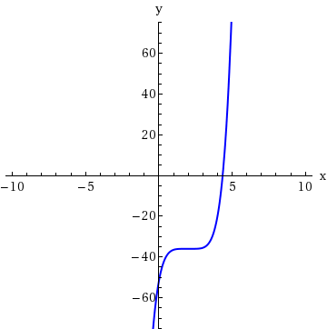

9.
[–/3 Points]DETAILSSPRECALC7 3.2.011.
MY NOTES
PRACTICE ANOTHER
A polynomial function is given.
R(x) = −x⁵ + 4x³ − 9x
(a) Describe the end behavior of the polynomial function.
End behavior: | y → |  | as x → ∞
 | y → |  | as x → −∞
(b) Match the polynomial function with one of the following graphs.
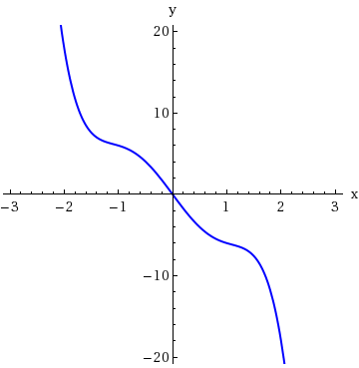

10.
[–/3 Points]DETAILSSPRECALC7 3.2.012.
MY NOTES
PRACTICE ANOTHER
A polynomial function is given.
S(x) =
3
2
x⁶ − 2x⁴
(a) Describe the end behavior of the polynomial function.
End behavior: | y → | as x → ∞
 | y → | as x → −∞
(b) Match the polynomial function with one of the following graphs.
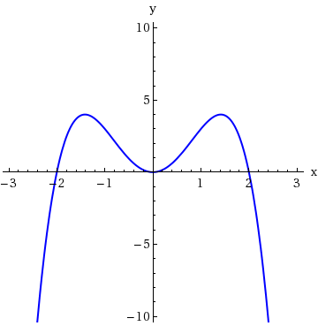 | 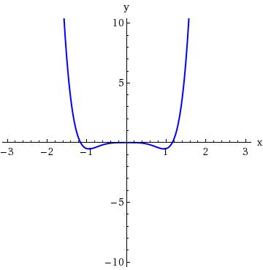
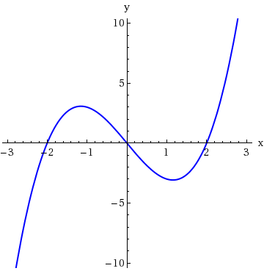 | 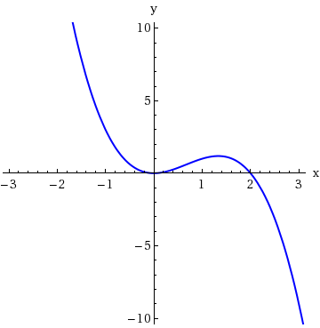
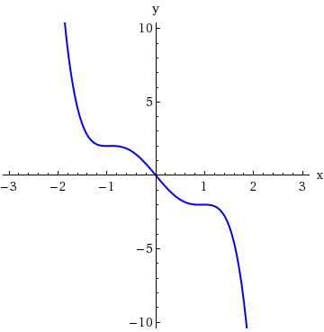 | 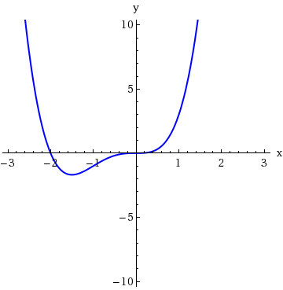
Find the quotient and remainder using long division.
x² − 5x + 15
x − 2
quotient
remainder

2.
[–/2 Points]DETAILSSPRECALC7 3.3.016.
MY NOTES
PRACTICE ANOTHER
Find the quotient and remainder using long division.
x³ + 7x² − x + 1
x + 8
quotient
remainder

3.
[–/2 Points]DETAILSSPRECALC7 3.3.017.
MY NOTES
PRACTICE ANOTHER
Find the quotient and remainder using long division.
4x³ + 2x² − 2x − 3
2x + 1
quotient
remainder

4.
[–/2 Points]DETAILSSPRECALC7 3.3.019.
MY NOTES
PRACTICE ANOTHER
Find the quotient and remainder using long division.
x³ + 2x + 2
x² − x + 3
quotient
remainder

5.
[–/2 Points]DETAILSSPRECALC7 3.3.021.
MY NOTES
PRACTICE ANOTHER
Find the quotient and remainder using long division.
9x³ + 3x² + 28x
3x² + 1
quotient
remainder

6.
[–/2 Points]DETAILSSPRECALC7 3.3.022.MI.
MY NOTES
PRACTICE ANOTHER
Find the quotient and remainder using long division.
6x² − x + 7
2x² − 8x
quotient
remainder

7.
[–/2 Points]DETAILSSPRECALC7 3.3.023.MI.
MY NOTES
PRACTICE ANOTHER
Find the quotient and remainder using long division.
x⁶ + 5x⁴ + 5x² + 25
x² + 5
quotient
remainder

8.
[–/2 Points]DETAILSSPRECALC7 3.3.025.MI.
MY NOTES
PRACTICE ANOTHER
Find the quotient and remainder using synthetic division.
2x² − 7x + 1
x − 4
quotient
remainder

9.
[–/2 Points]DETAILSSPRECALC7 3.3.026.
MY NOTES
PRACTICE ANOTHER
Find the quotient and remainder using synthetic division.
−x² + x − 3
x + 1
quotient
remainder

10.
[–/2 Points]DETAILSSPRECALC7 3.3.027.
MY NOTES
PRACTICE ANOTHER
Find the quotient and remainder using synthetic division.
4x² + x
x + 1
quotient
remainder
SPRECALC7 3.4.001.
MY NOTES
PRACTICE ANOTHER
If the polynomial function
P(x) = a_{n}x^{n} + a_{n−1}x^{n−1} + + a₁x + a₀
has integer coefficients, then the only numbers that could possibly be rational zeros of P are all of the form
p
q
,
where p is a factor of  and q is a factor of . The possible rational zeros of
P(x) = 10x³ + 3x² − 19x − 26
are

. (Enter your answers as a comma-separated list.)

2.
[–/4 Points]DETAILSSPRECALC7 3.4.002.
MY NOTES
PRACTICE ANOTHER
Using Descartes' Rule of Signs, we can tell that the polynomial
P(x) = x⁵ − 2x⁴ + 2x³ − x² + 8x − 4
has, from smallest to largest, , , or positive real zeros and negative real zeros.

3.
[–/1 Points]DETAILSSPRECALC7 3.4.003.
MY NOTES
If c is a real zero of the polynomial P, then all the other zeros of P are zeros of
P(x)/(x − c).

TrueFalse

4.
[–/1 Points]DETAILSSPRECALC7 3.4.005.MI.
MY NOTES
PRACTICE ANOTHER
List all possible rational zeros given by the Rational Zeros Theorem (but don't check to see which actually are zeros). (Enter your answers as a comma-separated list.)
P(x) = x³ − 8x² + 2
x =

5.
[–/1 Points]DETAILSSPRECALC7 3.4.006.MI.
MY NOTES
PRACTICE ANOTHER
List all possible rational zeros given by the Rational Zeros Theorem (but don't check to see which actually are zeros). (Enter your answers as a comma-separated list.)
Q(x) = x⁴ − 8x³ − 4x + 6
x =

6.
[–/1 Points]DETAILSSPRECALC7 3.4.007.
MY NOTES
PRACTICE ANOTHER
List all possible rational zeros given by the Rational Zeros Theorem (but don't check to see which actually are zeros). (Enter your answers as a comma-separated list.)
R(x) = 2x⁵ + 6x³ + 5x² − 6
x =

7.
[–/2 Points]DETAILSSPRECALC7 3.4.011.
MY NOTES
PRACTICE ANOTHER
A polynomial function P and its graph are given.
P(x) = 3x³ − x² − 3x + 1
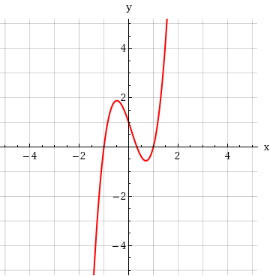
(a) List all possible rational zeros of P given by the Rational Zeros Theorem. (Enter your answers as a comma-separated list.)
x =

(b) From the graph, determine which of the possible rational zeros actually turn out to be zeros. (Enter your answers as a comma-separated list. Enter all answers including repetitions.)
x =

8.
[–/2 Points]DETAILSSPRECALC7 3.4.012.MI.
MY NOTES
PRACTICE ANOTHER
A polynomial function P and its graph are given.
P(x) = 3x³ + x² − 7x − 5
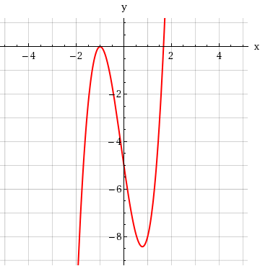
(a) List all possible rational zeros of P given by the Rational Zeros Theorem. (Enter your answers as a comma-separated list.)
x =

(b) From the graph, determine which of the possible rational zeros actually turn out to be zeros. (Enter your answers as a comma-separated list. Enter all answers including repetitions.)
x =

9.
[–/2 Points]DETAILSSPRECALC7 3.4.013.
MY NOTES
PRACTICE ANOTHER
A polynomial function P and its graph are given.
P(x) = 2x⁴ + 9x³ + 9x² − x − 3
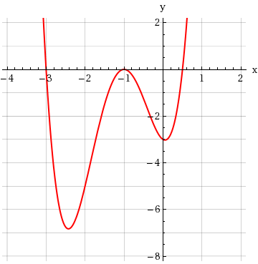
(a) List all possible rational zeros of P given by the Rational Zeros Theorem. (Enter your answers as a comma-separated list.)
x =

(b) From the graph, determine which of the possible rational zeros actually turn out to be zeros. (Enter your answers as a comma-separated list. Enter all answers including repetitions.)
x =

10.
[–/2 Points]DETAILSSPRECALC7 3.4.014.MI.
MY NOTES
PRACTICE ANOTHER
A polynomial function P and its graph are given.
P(x) = 4x⁴ − x³ − 4x + 1
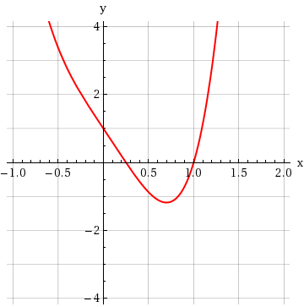
(a) List all possible rational zeros of P given by the Rational Zeros Theorem. (Enter your answers as a comma-separated list.)
x =

(b) From the graph, determine which of the possible rational zeros actually turn out to be zeros. (Enter your answers as a comma-separated list. Enter all answers including repetitions.)
x =

SPRECALC7 3.5.007.MI.
MY NOTES
PRACTICE ANOTHER
A polynomial P is given.
P(x) = x⁴ + 49x²
(a) Find all zeros of P, real and complex. (Enter your answers as a comma-separated list. Enter all answers including repetitions.)
x =
(b) Factor P completely.
P(x) =

2.
[–/2 Points]DETAILSSPRECALC7 3.5.008.MI.
MY NOTES
PRACTICE ANOTHER
A polynomial P is given.
P(x) = x⁵ + 81x³
(a) Find all zeros of P, real and complex. (Enter your answers as a comma-separated list. Enter all answers including repetitions.)
x =
(b) Factor P completely.
P(x) =

3.
[–/2 Points]DETAILSSPRECALC7 3.5.009.MI.
MY NOTES
PRACTICE ANOTHER
A polynomial P is given.
P(x) = x³ − 6x² + 18x
(a) Find all zeros of P, real and complex. (Enter your answers as a comma-separated list. Enter all answers including repetitions.)
x =
(b) Factor P completely.
P(x) =

4.
[–/2 Points]DETAILSSPRECALC7 3.5.011.MI.
MY NOTES
PRACTICE ANOTHER
A polynomial P is given.
P(x) = x⁴ + 18x² + 81
(a) Find all zeros of P, real and complex. (Enter your answers as a comma-separated list. Enter all answers including repetitions.)
x =
(b) Factor P completely.
P(x) =

5.
[–/2 Points]DETAILSSPRECALC7 3.5.012.MI.
MY NOTES
PRACTICE ANOTHER
A polynomial P is given.
P(x) = x⁴ − 6x² − 7
(a) Find all zeros of P, real and complex. (Enter your answers as a comma-separated list. Enter all answers including repetitions.)
x =
(b) Factor P completely.
P(x) =

6.
[–/2 Points]DETAILSSPRECALC7 3.5.013.MI.
MY NOTES
PRACTICE ANOTHER
A polynomial P is given.
P(x) = x⁴ − 256
(a) Find all zeros of P, real and complex. (Enter your answers as a comma-separated list. Enter all answers including repetitions.)
x =
(b) Factor P completely.
P(x) =

7.
[–/2 Points]DETAILSSPRECALC7 3.5.014.MI.
MY NOTES
PRACTICE ANOTHER
A polynomial P is given.
P(x) = x⁴ + 12x² + 36
(a) Find all zeros of P, real and complex. (Enter your answers as a comma-separated list. Enter all answers including repetitions.)
x =
(b) Factor P completely.
P(x) =

1.
[–/5 Points]DETAILSSPRECALC7 4.1.001.
MY NOTES
PRACTICE ANOTHER
The function
f(x) = 6^{x}
is an exponential function with base ; f(−2) = , f(0) = ,
f(2)
= , and f(6) = .

2.
[–/4 Points]DETAILSSPRECALC7 4.1.002.
MY NOTES
PRACTICE ANOTHER
Match the exponential function with its graph.
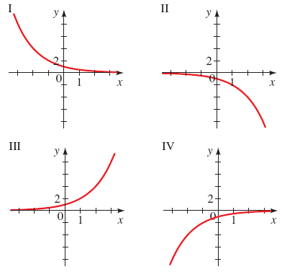
(a)
f(x) = 2^{x}
(b)
f(x) = 2^{−x}
(c)
f(x) = −2^{x}
(d)
f(x) = −2^{−x}

3.
[–/2 Points]DETAILSSPRECALC7 4.1.003.
MY NOTES
PRACTICE ANOTHER
(a) To obtain the graph of
g(x) = 6^{x} − 1,
we start with the graph of
f(x) = 6^{x}
and shift it 1 unit.
(b) To obtain the graph of
h(x) = 6^{x − 1},
we start with the graph of
f(x) = 6^{x}
and shift it to the 1 unit.

4.
[–/4 Points]DETAILSSPRECALC7 4.1.007.
MY NOTES
PRACTICE ANOTHER
Use a calculator to evaluate the function at the indicated values. Round your answers to three decimals.
f(x) = 9^{x}
f | =
  1
  2
f(  ) | =
  3
f(−2) | =
f(0.4) | =

5.
[–/4 Points]DETAILSSPRECALC7 4.1.008.
MY NOTES
PRACTICE ANOTHER
Use a calculator to evaluate the function at the indicated values. Round your answers to three decimals.
f(x) = 3^{x − 1}
f | =
  1
  2
f(1.5) | =
f(−1) | =
f | =
  1
  4

6.
[–/4 Points]DETAILSSPRECALC7 4.1.010.
MY NOTES
PRACTICE ANOTHER
Use a calculator to evaluate the function at the indicated values. Round your answers to three decimals.
g(x) =

6
5

5x

g  − | =
  1
  2
g(  ) | =
  6
g(−4) | =
g | =
  6
  5

7.
[–/6 Points]DETAILSSPRECALC7 4.1.011.
MY NOTES
PRACTICE ANOTHER
Sketch the graph of the function by making a table of values. Use a calculator if necessary. (Simplify your answers completely.)
f(x) = 2^{x}
x | f(x) = 2^{x}
−4
−2
0
2
4

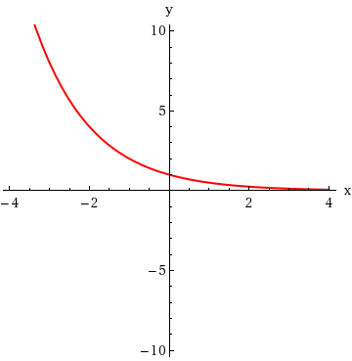 | 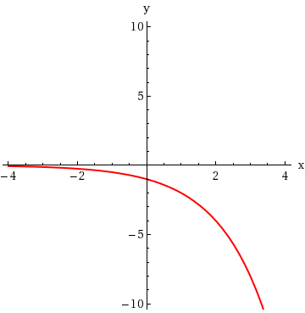
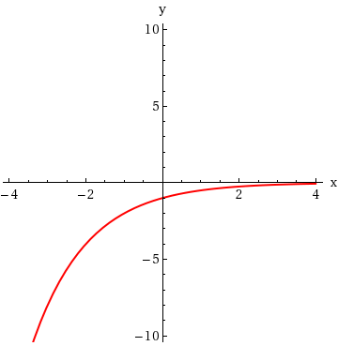 | 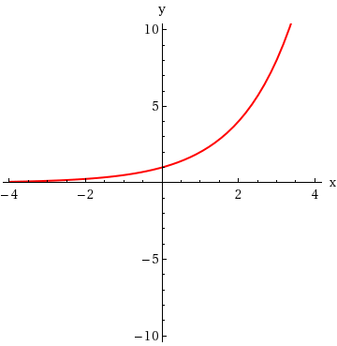

8.
[–/6 Points]DETAILSSPRECALC7 4.1.012.
MY NOTES
PRACTICE ANOTHER
Sketch the graph of the function by making a table of values. Use a calculator if necessary. (Simplify your answers completely.)
g(x) = 8^{x}
x | g(x) = 8^{x}
−2
−1
0
1
2

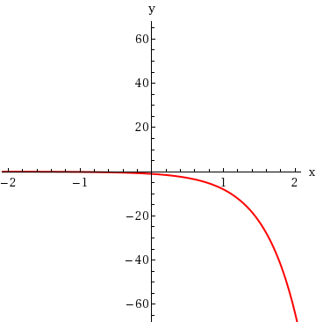 | 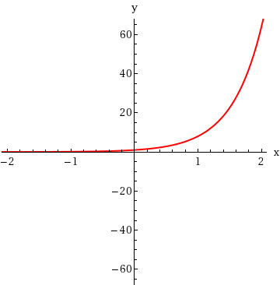
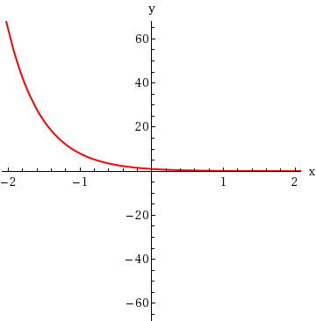 | 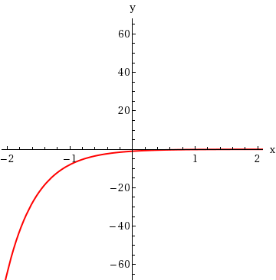

9.
[–/6 Points]DETAILSSPRECALC7 4.1.013.
MY NOTES
PRACTICE ANOTHER
Sketch the graph of the function by making a table of values. Use a calculator if necessary. (Simplify your answers completely.)
f(x) =

1
5

x

x | f(x) =
  1
  5
  x
−2
−1
0
1
2

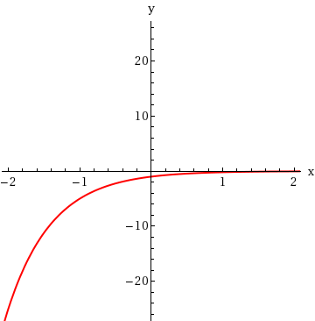 | 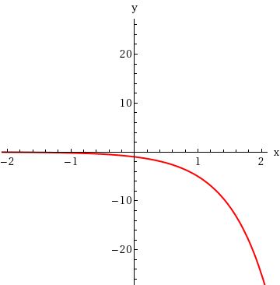
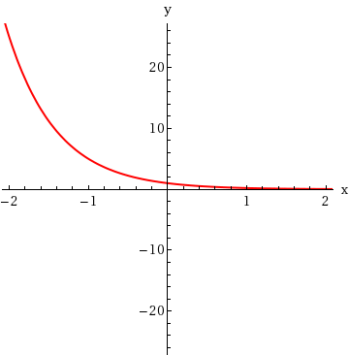 | 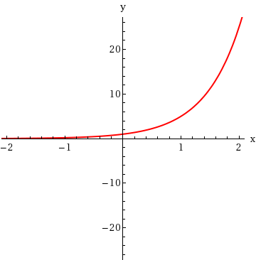

10.
[–/6 Points]DETAILSSPRECALC7 4.1.015.
MY NOTES
PRACTICE ANOTHER
Sketch the graph of the function by making a table of values. Use a calculator if necessary. (Simplify your answers completely. Round your answers to four decimal places.)
g(x) = 2(1.2)^{x}
x | g(x) = 2(1.2)^{x}
−5
−1
0
5
10

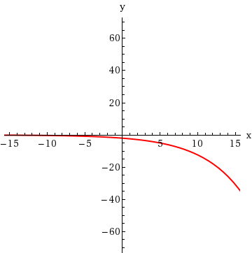 | 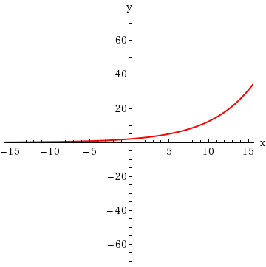
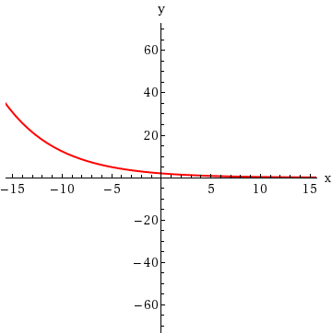 | 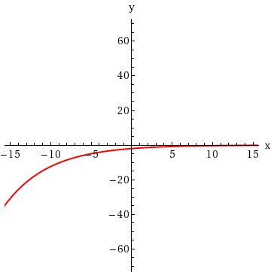
PRACTICE ANOTHER
Use a calculator to evaluate the function at the indicated values. Round your answers to three decimals.
h(x) = e^{x}; h(1), h(π), h(−5), h(
3
)
h(1) | =
h(π) | =
h(−5) | =
h(  ) | =
  3

2.
[–/4 Points]DETAILSSPRECALC7 4.2.004.
MY NOTES
PRACTICE ANOTHER
Use a calculator to evaluate the function at the indicated values. Round your answers to three decimals.
h(x) = e^{−2x}; h

1
4

, h(2.5), h(−1), h(−π)
h | =
  1
  4
h(2.5) | =
h(−1) | =
h(−π) | =

3.
[–/8 Points]DETAILSSPRECALC7 4.2.005.
MY NOTES
PRACTICE ANOTHER
Complete the table of values, rounded to two decimal places.
x | f(x) = 1.6e^{x}
−2
−1
−0.5
0
0.5
1
2
Sketch a graph of the function.
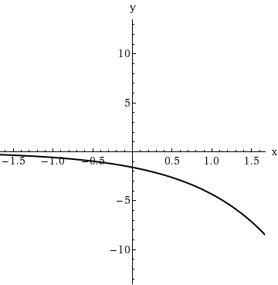 | 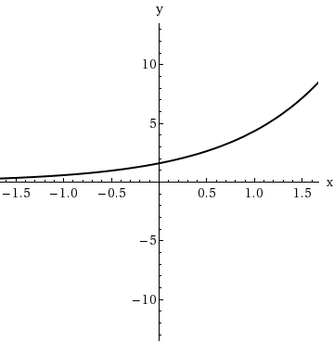
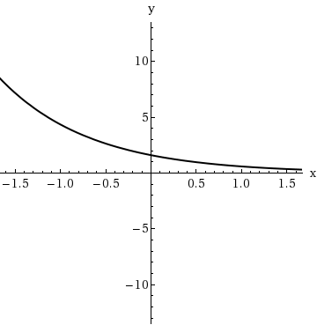 | 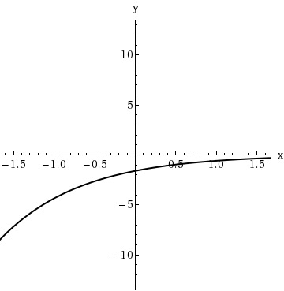

4.
[–/4 Points]DETAILSSPRECALC7 4.2.007.
MY NOTES
PRACTICE ANOTHER
Graph the function, not by plotting points, but by starting from the graph of
y = e^{x}
in the figure below.
g(x) = 1 + e^{x}
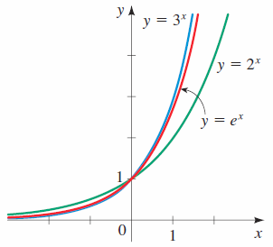
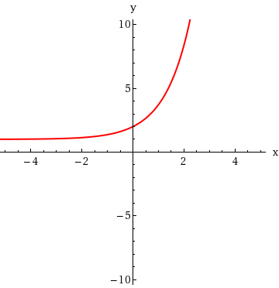 | 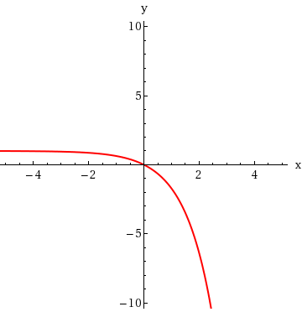
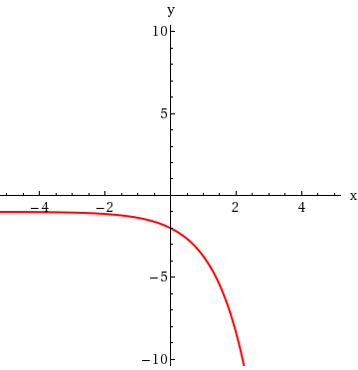 | 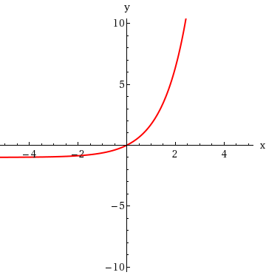
State the domain and range. (Enter your answers using interval notation.)
domain
range
State the asymptote.

5.
[–/4 Points]DETAILSSPRECALC7 4.2.008.
MY NOTES
PRACTICE ANOTHER
Graph the function, not by plotting points, but by starting from the graph of
y = e^{x}
in the figure below.
h(x) = e^{−x} − 3
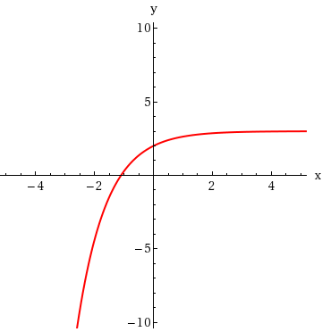 | 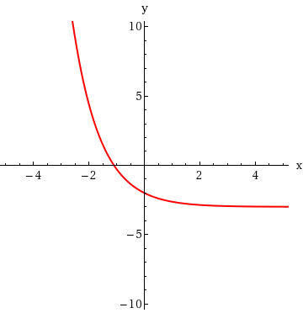
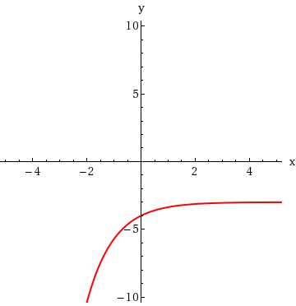 | 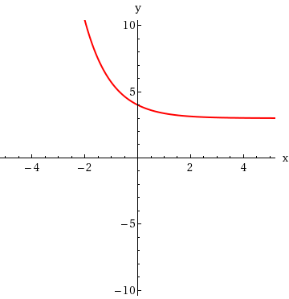
State the domain and range. (Enter your answers using interval notation.)
domain
range
State the asymptote.

6.
[–/4 Points]DETAILSSPRECALC7 4.2.009.
MY NOTES
Graph the function, not by plotting points, but by starting from the graph of
y = e^{x}
in the figure below.
f(x) = −e^{x}
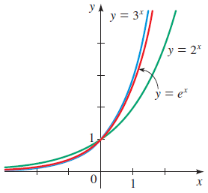
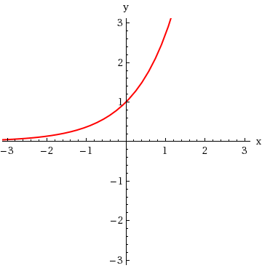 | 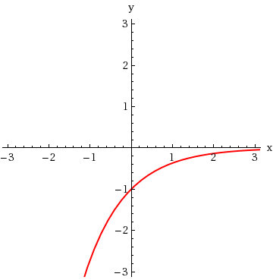
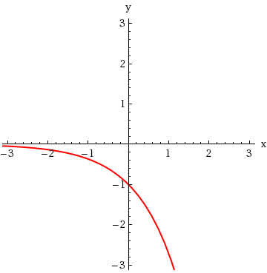 | 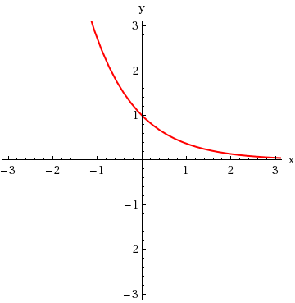
State the domain and range. (Enter your answers using interval notation.)
domain
range
State the asymptote.

7.
[–/4 Points]DETAILSSPRECALC7 4.2.010.
MY NOTES
PRACTICE ANOTHER
Graph the function, not by plotting points, but by starting from the graph of
y = e^{x}
in the figure below.
y = 6 − e^{x}
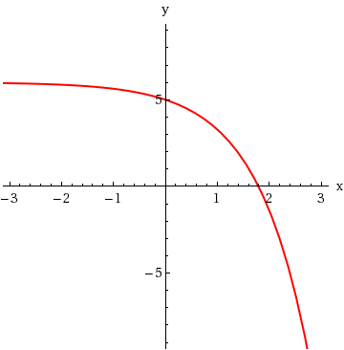 | 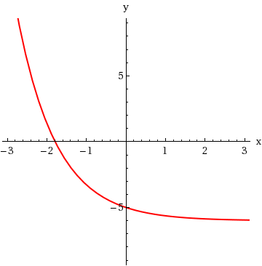
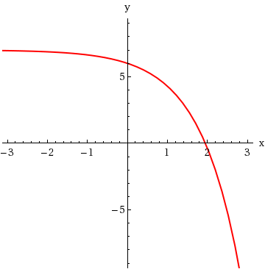 | 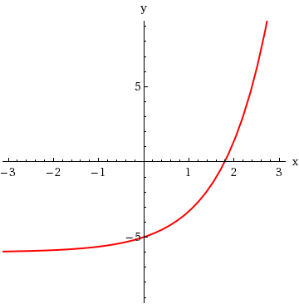
State the domain and range. (Enter your answers using interval notation.)
domain
range
State the asymptote.

8.
[–/4 Points]DETAILSSPRECALC7 4.2.011.
MY NOTES
PRACTICE ANOTHER
Graph the function, not by plotting points, but by starting from the graph of
y = e^{x}
in the figure below.
y = e^{−x} − 1
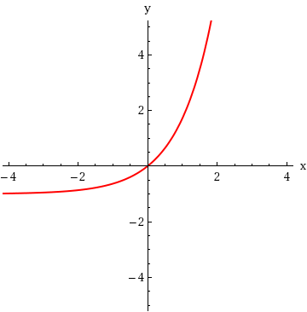 | 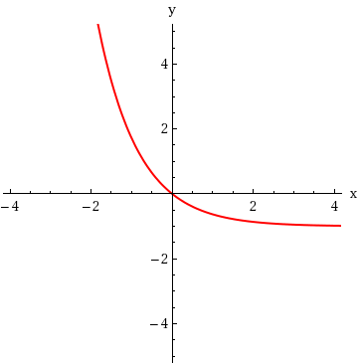
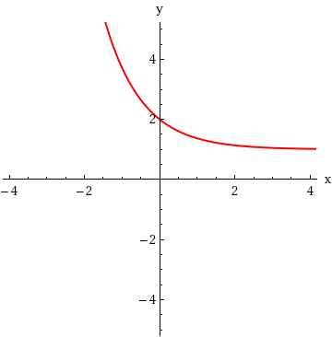 | 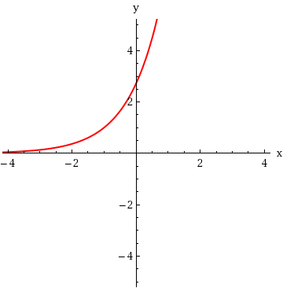
State the domain and range. (Enter your answers using interval notation.)
domain
range
State the asymptote.

9.
[–/4 Points]DETAILSSPRECALC7 4.2.012.MI.
MY NOTES
Graph the function, not by plotting points, but by starting from the graph of
y = e^{x}
in the figure below.
f(x) = −e^{−x}
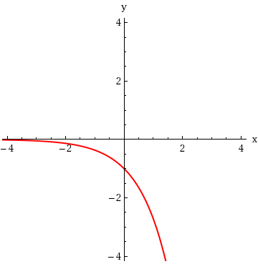 | 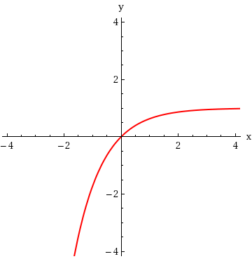
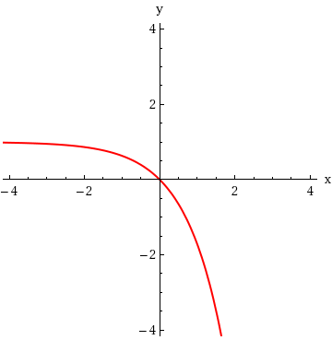 | 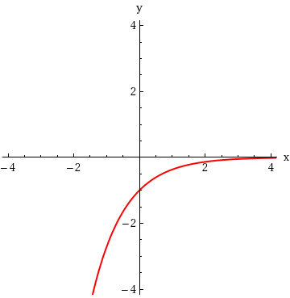
State the domain and range. (Enter your answers using interval notation.)
domain
range
State the asymptote.

10.
[–/5 Points]DETAILSSPRECALC7 4.2.025.MI.
MY NOTES
PRACTICE ANOTHER
A graphing calculator is recommended.
A sky diver jumps from a reasonable height above the ground. The air resistance she experiences is proportional to her velocity, and the constant of proportionality is 0.15. It can be shown that the downward velocity of the sky diver at time t is given by
v(t) = 160(1 − e^{−0.15t})
where t is measured in seconds (s) and v(t) is measured in feet per second (ft/s).
(a) Find the initial velocity of the sky diver.
ft/s
(b) Find the velocity after 4 s and after 14 s. (Round your answers to one decimal place.)
after 4 s |  | ft/s
after 14 s |  | ft/s
(c) Draw a graph of the velocity function v(t).
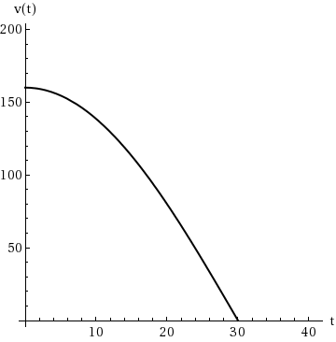 | 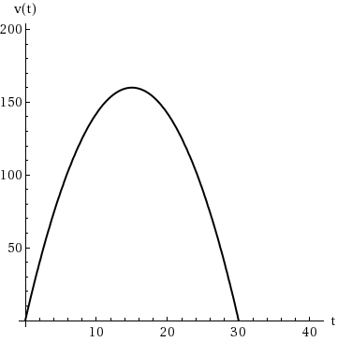
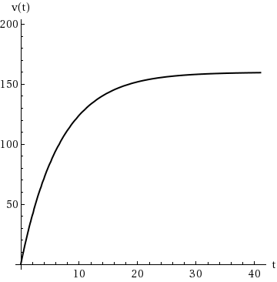 | 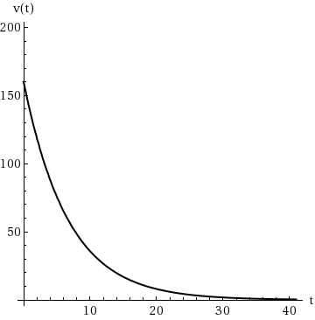
(d) The maximum velocity of a falling object with wind resistance is called its terminal velocity. From the graph in part (c) find the terminal velocity of this sky diver. (Round your answer to the nearest whole number.)
ft/s

11.
[–/2 Points]DETAILSSPRECALC7 4.2.024.
MY NOTES
PRACTICE ANOTHER
A radioactive substance decays in such a way that the amount of mass remaining after t days is given by the function
m(t) = 14e^{−0.016t}
where m(t) is measured in kilograms.
(a) Find the mass at time t = 0.
kg
(b) How much of the mass remains after 46 days? (Round your answer to one decimal place.)
kg

12.
[–/4 Points]DETAILSSPRECALC7 4.2.026.MI.
MY NOTES
PRACTICE ANOTHER
A graphing calculator is recommended.
A 30-gallon barrel is filled completely with pure water. Salt water with a concentration of 0.3 lb/gal is then pumped into the barrel, and the resulting mixture overflows at the same rate. The amount of salt in the barrel at time t is given by
Q(t) = 9(1 − e^{−0.01t})
where t is measured in minutes and Q(t) is measured in pounds.

(a) How much salt is in the barrel after 4 min? (Round your answer to two decimal places.)
lb
(b) How much salt is in the barrel after 8 min? (Round your answer to two decimal places.)
lb
(c) Draw a graph of the function Q(t).
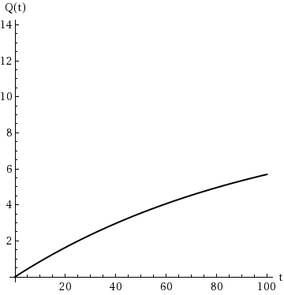 | 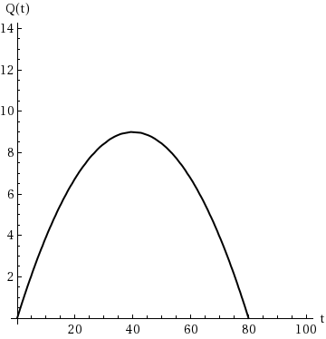
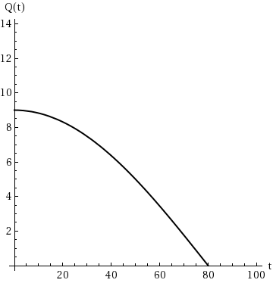 | 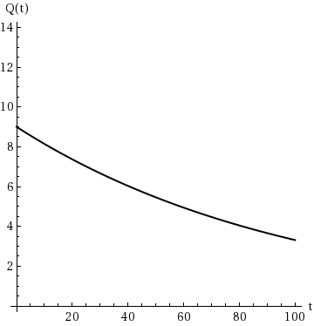
(d) Use the graph in part (c) to determine the value that the amount of salt in the barrel approaches as t becomes large.
lb
PRACTICE ANOTHER
Express the equation in logarithmic form.
(a)
16⁻¹ =
1
16

(b)
2⁻⁴ =
1
16

2.
[–/2 Points]DETAILSSPRECALC7 4.3.020.
MY NOTES
PRACTICE ANOTHER
Express the equation in logarithmic form.
(a)
4^{−3/2} = 0.125

(b)
8³ = 512

3.
[–/2 Points]DETAILSSPRECALC7 4.3.021.
MY NOTES
PRACTICE ANOTHER
Express the equation in logarithmic form.
(a)
2^{x} = 50

(b)
3⁵ = w

4.
[–/2 Points]DETAILSSPRECALC7 4.3.022.
MY NOTES
PRACTICE ANOTHER
Express the equation in logarithmic form.
(a)
3^{5x} = 20

(b)
10^{−3x} = 0.01

5.
[–/2 Points]DETAILSSPRECALC7 4.3.023.
MY NOTES
PRACTICE ANOTHER
Express the equation in logarithmic form.
(a)
e^{x} = 5

(b)
e⁹ = y

6.
[–/2 Points]DETAILSSPRECALC7 4.3.024.
MY NOTES
PRACTICE ANOTHER
Express the equation in logarithmic form.
(a)
e^{x + 3} = 0.3

(b)
e^{0.8x} = t

7.
[–/3 Points]DETAILSSPRECALC7 4.3.025.MI.
MY NOTES
PRACTICE ANOTHER
Evaluate the expression. (Simplify your answer completely.)
(a) log₃(3)

(b) log₃(1)

(c) log₅(5⁴)

8.
[–/3 Points]DETAILSSPRECALC7 4.3.026.MI.
MY NOTES
PRACTICE ANOTHER
Evaluate the expression. (Simplify your answer completely.)
(a) log₅(5⁷)

(b) log₄(256)

(c) log₆(216)

9.
[–/3 Points]DETAILSSPRECALC7 4.3.027.MI.
MY NOTES
PRACTICE ANOTHER
Evaluate the expression. (Simplify your answer completely.)
(a) log₉(81)

(b) log₇(49)

(c) log₉(9¹³)

10.
[–/3 Points]DETAILSSPRECALC7 4.3.028.MI.
MY NOTES
PRACTICE ANOTHER
Evaluate the expression. (Simplify your answer completely.)
(a) log₂(32)

(b) log₈(8¹⁹)

(c) log₆(1)

11.
[–/3 Points]DETAILSSPRECALC7 4.3.029.MI.
MY NOTES
PRACTICE ANOTHER
Evaluate the expression. (Simplify your answer completely.)
(a)
log₃

1
243

(b) log₈(√8)

(c) log₂(0.5)

12.
[–/3 Points]DETAILSSPRECALC7 4.3.030.MI.
MY NOTES
PRACTICE ANOTHER
Evaluate the expression. (Simplify your answer completely.)
(a)
log₅(625)

(b)
log₁₆(4)

(c)
log₂₅(
5
)

13.
[–/3 Points]DETAILSSPRECALC7 4.3.031.MI.
MY NOTES
PRACTICE ANOTHER
Evaluate the expression. (Simplify your answer completely.)
(a)
4^{log}₄⁽⁷⁾

(b)
5^{log}₅⁽²⁴⁾

(c)
e^{ln(30)}

14.
[–/3 Points]DETAILSSPRECALC7 4.3.032.MI.
MY NOTES
PRACTICE ANOTHER
Evaluate the expression. (Simplify your answer completely.)
(a)
e^{ln(√7)}

(b)
e^{ln(1/π)}

(c)
10^{log(18)}

15.
[–/3 Points]DETAILSSPRECALC7 4.3.033.MI.
MY NOTES
PRACTICE ANOTHER
Evaluate the expression. (Simplify your answer completely.)
(a)
log₈(0.5)

(b)
ln(e¹⁰)

(c)
ln(1/e)

1.
[–/2 Points]DETAILSSPRECALC7 4.4.004.
MY NOTES
PRACTICE ANOTHER
(a) We can expand
log  to get |  | .
  x⁶y
  z
(b) We can combine
6 log x + log y − log z to get |  | .

2.
[–/6 Points]DETAILSSPRECALC7 4.4.006.
MY NOTES
PRACTICE ANOTHER
(a) Most calculators can find logarithms with base and base e. To find logarithms with different bases, we use the . To find log₅(8), we write the following. (Round your answers to three decimal places.)
log₅(8) =
log

log

≈
(b) Do we get the same answer if we perform the calculation in part (a) using ln in place of log?
Yes, the result is the same.No, the result is not the same.

3.
[–/2 Points]DETAILSSPRECALC7 4.4.008.
MY NOTES
PRACTICE ANOTHER
True or False?
(a)
log

G
B

is the same as
log(G) − log(B).

TrueFalse
(b)
log(G)
log(B)
is the same as
log(G) − log(B).

TrueFalse

4.
[–/1 Points]DETAILSSPRECALC7 4.4.009.
MY NOTES
PRACTICE ANOTHER
Use the Laws of Logarithms to evaluate the expression.
log(500) + log(200)

5.
[–/1 Points]DETAILSSPRECALC7 4.4.010.MI.
MY NOTES
PRACTICE ANOTHER
Use the Laws of Logarithms to evaluate the expression.
log₆(36) + log₆(6)

6.
[–/1 Points]DETAILSSPRECALC7 4.4.011.MI.
MY NOTES
PRACTICE ANOTHER
Use the Laws of Logarithms to evaluate the expression.
log₄(192) − log₄(12)

7.
[–/1 Points]DETAILSSPRECALC7 4.4.012.MI.
MY NOTES
PRACTICE ANOTHER
Use the Laws of Logarithms to evaluate the expression.
log₃(1134) − log₃(42)

8.
[–/1 Points]DETAILSSPRECALC7 4.4.013.
MY NOTES
PRACTICE ANOTHER
Use the Laws of Logarithms to evaluate the expression.
1
4
log₃(81)

9.
[–/1 Points]DETAILSSPRECALC7 4.4.014.
MY NOTES
PRACTICE ANOTHER
Use the Laws of Logarithms to evaluate the expression.
−
1
3
log₄(64)

10.
[–/1 Points]DETAILSSPRECALC7 4.4.015.
MY NOTES
PRACTICE ANOTHER
Use the Laws of Logarithms to evaluate the expression.
log₂(
2
)

11.
[–/1 Points]DETAILSSPRECALC7 4.4.016.
MY NOTES
PRACTICE ANOTHER
Use the Laws of Logarithms to evaluate the expression.
log₅

1
125

12.
[–/1 Points]DETAILSSPRECALC7 4.4.017.MI.
MY NOTES
PRACTICE ANOTHER
Use the Laws of Logarithms to evaluate the expression.
log₃(15) − log₃(35) + log₃(189)

13.
[–/1 Points]DETAILSSPRECALC7 4.4.018.MI.
MY NOTES
PRACTICE ANOTHER
Use the Laws of Logarithms to evaluate the expression.
log₅(16) − log₅(8) − log₅(50)

14.
[–/1 Points]DETAILSSPRECALC7 4.4.019.MI.
MY NOTES
PRACTICE ANOTHER
Use the Laws of Logarithms to evaluate the expression.
log₅(25³⁰⁰)

15.
[–/1 Points]DETAILSSPRECALC7 4.4.020.MI.
MY NOTES
PRACTICE ANOTHER
Use the Laws of Logarithms to evaluate the expression.
log₂(8⁸⁵)
SPRECALC7 4.5.001.
MY NOTES
PRACTICE ANOTHER
Let's solve the exponential equation
4e^{x} = 100.
(a) First, we isolate
e^{x}
to get the equivalent equation

.
(b) Next, we take ln of each side to get the equivalent equation

.
(c) Now we use a calculator to find
x ≈ .
(Round your answer to three decimal places.)

2.
[–/3 Points]DETAILSSPRECALC7 4.5.002.
MY NOTES
PRACTICE ANOTHER
Let's solve the logarithmic equation
log(3) + log(x − 2) = log(x).
(a) First, we combine the logarithms on the LHS to get the equivalent equation

= log(x).
(b) Next, we use the fact that log is one-to-one to get the equivalent equation

= x.
(c) Now we find x = .

3.
[–/1 Points]DETAILSSPRECALC7 4.5.004.
MY NOTES
PRACTICE ANOTHER
Find the solution of the exponential equation, as in Example 1. (Enter your answers as a comma-separated list.)
e^{x2} = e⁹
x =

4.
[–/1 Points]DETAILSSPRECALC7 4.5.005.
MY NOTES
PRACTICE ANOTHER
Find the solution of the exponential equation, as in Example 1. (Enter your answers as a comma-separated list.)
2^{2x − 3} = 1
x =

5.
[–/1 Points]DETAILSSPRECALC7 4.5.006.
MY NOTES
PRACTICE ANOTHER
Find the solution of the exponential equation, as in Example 1. (Enter your answers as a comma-separated list.)
7^{2x − 3} =
1
7
x =

6.
[–/1 Points]DETAILSSPRECALC7 4.5.007.
MY NOTES
PRACTICE ANOTHER
Find the solution of the exponential equation, as in Example 1. (Enter your answers as a comma-separated list.)
8^{2x − 4} = 8^{5 + 5x}
x =

7.
[–/1 Points]DETAILSSPRECALC7 4.5.008.
MY NOTES
PRACTICE ANOTHER
Find the solution of the exponential equation, as in Example 1. (Enter your answers as a comma-separated list.)
e^{1 − 2x} = e^{3x − 5}
x =

8.
[–/1 Points]DETAILSSPRECALC7 4.5.009.
MY NOTES
PRACTICE ANOTHER
Find the solution of the exponential equation, as in Example 1. (Enter your answers as a comma-separated list.)
7^{x2 − 4} = 7^{4 − x2}
x =

9.
[–/1 Points]DETAILSSPRECALC7 4.5.010.
MY NOTES
PRACTICE ANOTHER
Find the solution of the exponential equation, as in Example 1. (Enter your answers as a comma-separated list.)
8^{3x2 − 7} = 8^{9 − x2}
x =

10.
[–/2 Points]DETAILSSPRECALC7 4.5.012.
MY NOTES
PRACTICE ANOTHER
Consider the following.
10^{−x} = 121
(a) Find the exact solution of the exponential equation in terms of logarithms.
x =

(b) Use a calculator to find an approximation to the solution rounded to six decimal places.
x =

11.
[–/2 Points]DETAILSSPRECALC7 4.5.013.
MY NOTES
PRACTICE ANOTHER
Consider the following.
e^{−4x} = 10
(a) Find the exact solution of the exponential equation in terms of logarithms.
x =

(b) Use a calculator to find an approximation to the solution rounded to six decimal places.
x =

12.
[–/2 Points]DETAILSSPRECALC7 4.5.014.
MY NOTES
PRACTICE ANOTHER
Consider the following.
e^{0.4x} = 3
(a) Find the exact solution of the exponential equation in terms of logarithms.
x =

(b) Use a calculator to find an approximation to the solution rounded to six decimal places.
x =

13.
[–/2 Points]DETAILSSPRECALC7 4.5.015.MI.
MY NOTES
PRACTICE ANOTHER
Consider the following.
2^{2 − x} = 9
(a) Find the exact solution of the exponential equation in terms of logarithms.
x =

(b) Use a calculator to find an approximation to the solution rounded to six decimal places.
x =

14.
[–/2 Points]DETAILSSPRECALC7 4.5.016.
MY NOTES
PRACTICE ANOTHER
Consider the following.
5^{5x − 1} = 8
(a) Find the exact solution of the exponential equation in terms of logarithms.
x =

(b) Use a calculator to find an approximation to the solution rounded to six decimal places.
x =

15.
[–/2 Points]DETAILSSPRECALC7 4.5.018.MI.
MY NOTES
PRACTICE ANOTHER
Consider the following.
2e^{11x} = 9
(a) Find the exact solution of the exponential equation in terms of logarithms.
x =

(b) Use a calculator to find an approximation to the solution rounded to six decimal places.
x =

1.
[–/3 Points]DETAILSSPRECALC7 4.6.001.
MY NOTES
PRACTICE ANOTHER
This exercise uses the population growth model.
A certain culture of the bacterium Streptococcus A initially has 8 bacteria and is observed to double every 1.5 hours.
(a) Find an exponential model
n(t) = n₀2^{t/a}
for the number of bacteria in the culture after t hours.
n(t) =

(b) Estimate the number of bacteria after 28 hours. (Round your answer to the nearest whole number.)
bacteria
(c) After how many hours will the bacteria count reach 10,000? (Round your answer to one decimal place.)
t = h

2.
[–/3 Points]DETAILSSPRECALC7 4.6.002.
MY NOTES
PRACTICE ANOTHER
This exercise uses the population growth model.
A certain culture of the bacterium Rhodobacter sphaeroides initially has 30 bacteria and is observed to double every 6 hours.
(a) Find an exponential model
n(t) = n₀2^{t/a}
for the number of bacteria in the culture after t hours.
n(t) =

(b) Estimate the number of bacteria after 15 hours. (Round your answer to the nearest whole number.)
bacteria
(c) After how many hours will the bacteria count reach 1 million? (Round your answer to one decimal place.)
t = hr

3.
[–/3 Points]DETAILSSPRECALC7 4.6.003.
MY NOTES
PRACTICE ANOTHER
This exercise uses the population growth model.
A grey squirrel population was introduced in a certain county of Great Britain 30 years ago. Biologists observe that the population doubles every 6 years, and now the population is 80,000.
(a) What was the initial size of the squirrel population?
squirrels
(b) Estimate the squirrel population 10 years from now. (Round your answer to the nearest whole number.)
squirrels
(c) Sketch a graph of the squirrel population. (Assume t = 0 corresponds to the initial introduction.)
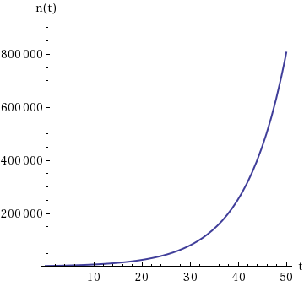 | 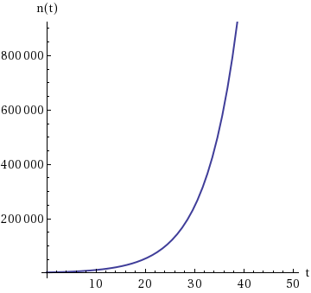
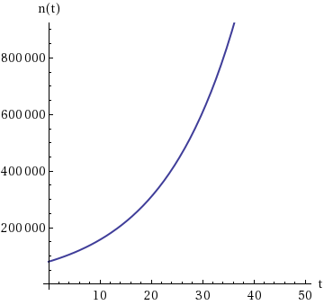 | 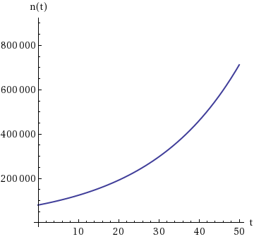

4.
[–/3 Points]DETAILSSPRECALC7 4.6.004.
MY NOTES
PRACTICE ANOTHER
This exercise uses the population growth model.
A certain species of bird was introduced in a certain county 25 years ago. Biologists observe that the population doubles every 10 years, and now the population is 14,000.
(a) What was the initial size of the bird population? (Round your answer to the nearest whole number.)
birds
(b) Estimate the bird population 8 years from now. (Round your answer to the nearest whole number.)
birds
(c) Sketch a graph of the bird population. (Assume t = 0 corresponds to the initial introduction.)
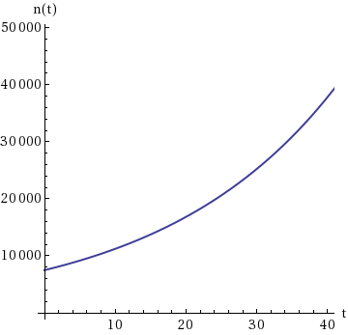 | 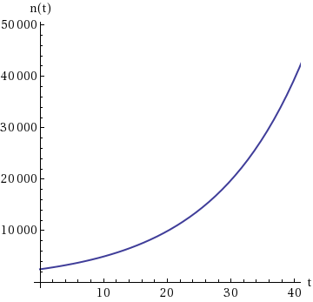
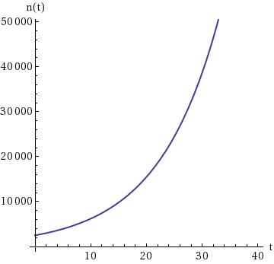 | 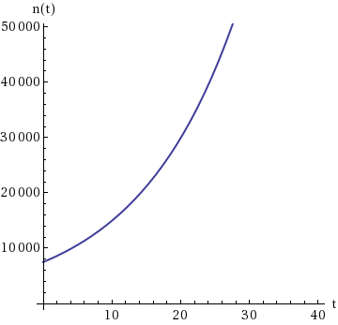

5.
[–/4 Points]DETAILSSPRECALC7 4.6.005.MI.
MY NOTES
PRACTICE ANOTHER
This exercise uses the population growth model.
The fox population in a certain region has a relative growth rate of 9% per year. It is estimated that the population in 2013 was 17,000.
(a) Find a function
n(t) = n₀e^{rt}
that models the population t years after 2013.
n(t) =

(b) Use the function from part (a) to estimate the fox population in the year 2020. (Round your answer to the nearest whole number.)
foxes
(c) After how many years will the fox population reach 23,000? (Round your answer to one decimal place.)
yr
(d) Sketch a graph of the fox population function for the years 2013–2021.
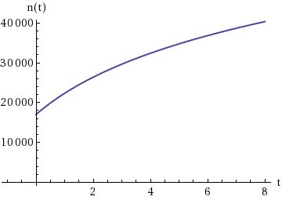 | 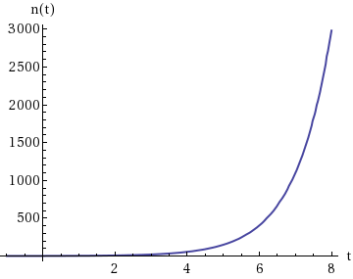
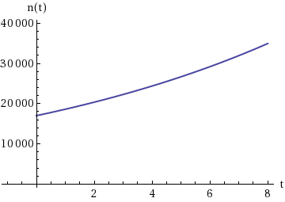 | 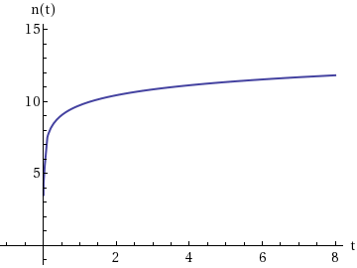
PRACTICE ANOTHER
The hydrogen ion concentration of a sample of each substance is given. Calculate the pH of the substance. (Round your answers to one decimal place.)
(a) Oranges: [H⁺] =
2.5 × 10⁻⁴
M
(b) Tomato Juice: [H⁺] =
3.2 × 10⁻⁴
M
(c) Hominy (lye): [H⁺] =
3.9 × 10⁻¹³
M

2.
[–/2 Points]DETAILSSPRECALC7 4.7.002.MI.
MY NOTES
PRACTICE ANOTHER
An unknown substance has the hydrogen ion concentration of [H⁺] = 3.5 10⁻⁸ M. Find the pH. (Round your answer to one decimal place.)
Classify the substance as acidic or basic.

3.
[–/4 Points]DETAILSSPRECALC7 4.7.003.MI.
MY NOTES
PRACTICE ANOTHER
The pH reading of a sample of each substance is given. Calculate the hydrogen ion concentration of the substance. (Give your answers in scientific notation, correct to one decimal place.)
(a) Spinach: pH = 5.4
[H⁺] = × 10 M
(b) Crackers: pH = 7.2
[H⁺] = × 10 M

4.
[–/4 Points]DETAILSSPRECALC7 4.7.004.MI.
MY NOTES
PRACTICE ANOTHER
The pH reading of a glass of liquid is given. Find the hydrogen ion concentration of the liquid. (Give your answers in scientific notation, correct to one decimal place.)
(a) Beer: pH = 4.3
[H⁺] = × 10 M
(b) Water: pH = 7.5
[H⁺] = × 10 M
In this exercise we find the area of a plane figure.
Draw the rectangle with vertices
A(2, 4), B(9, 4), C(2, −4), and D(9, −4)
on a coordinate plane.

Find the area of the rectangle.

2.
[–/2 Points]DETAILSSPRECALC7 1.9.032.MI.
MY NOTES
PRACTICE ANOTHER
In this exercise we find the area of a plane figure.
Draw the parallelogram with vertices
A(3, 2), B(7, 2), C(5, 9), and D(9, 9)
on a coordinate plane.

WebAssign Graphing Tool

Graph LayersToggle Open/Closed
- After you add an object to the graph you can use Graph Layers to view and edit its properties.
Find the area of the parallelogram.

3.
[–/3 Points]DETAILSSPRECALC7 1.9.033.MI.
MY NOTES
PRACTICE ANOTHER
In this exercise we find the area of a plane figure.
Plot the points
A(4, 0), B(9, 0), C(8, 8), and D(5, 8)

What kind of quadrilateral is ABCD?
a squarea rectangle, but not a square a parallelogram, but not a rectanglea trapezoidnone of the above
What is its area?

4.
[–/3 Points]DETAILSSPRECALC7 1.9.034.MI.
MY NOTES
PRACTICE ANOTHER
In this exercise we find the area of a plane figure.
Plot the points
P(6, 1), Q(0, 7), and R(−6, 1)

Where must the point S be located so that the quadrilateral PQRS is a square?
(x, y) =

Find the area of this square.

5.
[–/1 Points]DETAILSSPRECALC7 1.9.036.MI.
MY NOTES
PRACTICE ANOTHER
In this exercise we use the Distance Formula.
Which of the points
C(−6, 3) or D(3, 0)
is closer to the point
E(−2, 1)?
Point C is closer to point E.Point D is closer to point E. Points C and D are the same distance from point E.

6.
[–/4 Points]DETAILSSPRECALC7 1.9.039.
MY NOTES
PRACTICE ANOTHER
In this exercise we use the Distance Formula.
Show that the triangle with vertices
A(1, 3), B(−3, −1), and C(−7, 7)
is isosceles.
We must first find the length of all three sides of the triangle by finding the distance between the vertices.
d(A, B) | =
d(B, C) | =
d(A, C) | =
Therefore, the following conclusion can be reached.
AB and BC have the same length, so the triangle is isosceles.AB and AC have the same length, so the triangle is isosceles. BC and AC have the same length, so the triangle is isosceles.All sides have the same length, so the triangle is isosceles.All sides have different lengths, so the triangle is isosceles.

7.
[–/1 Points]DETAILSSPRECALC7 1.9.040.MI.
MY NOTES
PRACTICE ANOTHER
Find the area of the triangle shown in the figure.
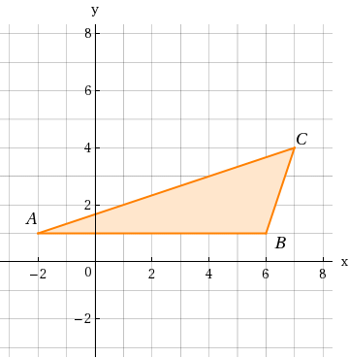

8.
[–/4 Points]DETAILSSPRECALC7 1.9.049.
MY NOTES
PRACTICE ANOTHER
In this exercise we use the Distance Formula and the Midpoint Formula.
(a) Sketch the parallelogram with vertices
A(−6, −5), B(2, −2), C(5, 3), and D(−3, 0).

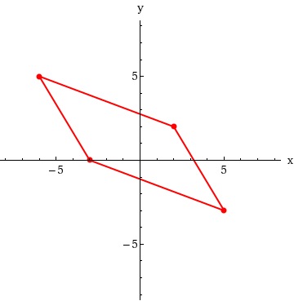 | 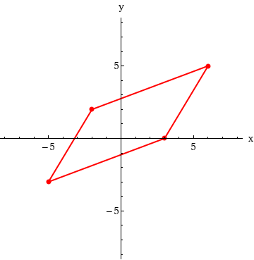
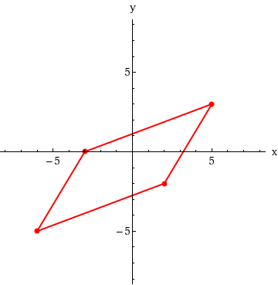 | 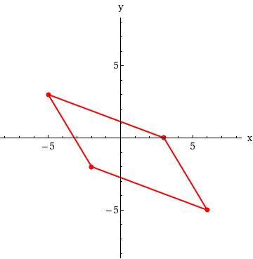
(b) Find the midpoints of the diagonals of this parallelogram.
midpoint of AC | (x, y) | =
midpoint of BD | (x, y) | =
(c) From part (b), show that the diagonals bisect each other.
Since the diagonals  , we conclude that the diagonals bisect each other.

9.
[–/2 Points]DETAILSSPRECALC7 1.9.047.
MY NOTES
PRACTICE ANOTHER
In this exercise we use the Distance Formula and the Midpoint Formula.
Plot the points
P(−1, −6), Q(1, 1), and R(4, 2)

WebAssign Graphing Tool

Where should the point S be located so that the figure PQRS is a parallelogram?
(x, y) =

10.
[–/3 Points]DETAILSSPRECALC7 1.9.046.
MY NOTES
PRACTICE ANOTHER
In this exercise we use the Distance Formula and the Midpoint Formula.
Find the lengths of the medians of the triangle with vertices A(1, 1), B(2, 7), and C(7, 2). (A median is a line segment from a vertex to the midpoint of the opposite side. Round your answers to one decimal place.)
length of median AA' | units
length of median BB' | units
length of median CC' | units

11.
[–/5 Points]DETAILSSPRECALC7 1.9.044.
MY NOTES
PRACTICE ANOTHER
In this exercise we use the Distance Formula.
Show that the points
A(−1, −1), B(1, 5), and C(2, 8)
are collinear by showing that
d(A, B) + d(B, C) = d(A, C).
We must first find
d(A, B) + d(B, C) and d(A, C).

d(A, B) | =
d(B, C) | =
d(A, C) | =
Thus, we see that
d(A, B) + d(B, C) d(A, C),
so the points collinear.

12.
[–/1 Points]DETAILSSPRECALC7 1.9.051.
MY NOTES
PRACTICE ANOTHER
Determine whether the given points are on the graph of the equation. (Select all that apply.)
x − 2y − 3 = 0; (0, 0), (3, 0), (−3, −3)
The point (0, 0) is on the graph of the equation.
The point (3, 0) is on the graph of the equation.
The point (−3, −3) is on the graph of the equation.
None of these points are on the graph of the equation.

13.
[–/1 Points]DETAILSSPRECALC7 1.9.052.
MY NOTES
PRACTICE ANOTHER
Determine whether the given points are on the graph of the equation. (Select all that apply.)
y(x² + 1) = 1; (1, 1),
2,
1
5

,
−2,
1
5

The point (1, 1) is on the graph of the equation.
The point
2,
1
5

is on the graph of the equation.
The point
−2,
1
5

is on the graph of the equation.
None of these points are on the graph of the equation.

14.
[–/1 Points]DETAILSSPRECALC7 1.9.053.
MY NOTES
PRACTICE ANOTHER
Determine whether the given points are on the graph of the equation. (Select all that apply.)
x² + xy + y² = 4; (0, −2), (1, −2), (2, −2)
The point (0, −2) is on the graph of the equation.
The point (1, −2) is on the graph of the equation.
The point (2, −2) is on the graph of the equation.

None of these points are on the graph of the equation.

15.
[–/1 Points]DETAILSSPRECALC7 1.9.054.
MY NOTES
PRACTICE ANOTHER
Determine whether the given points are on the graph of the equation. (Select all that apply.)
x² + y² = 1; (0, 1),

1
2

,
1
2

,

3

2
,
1
2

The point (0, 1) is on the graph of the equation.
The point

1
2

,
1
2

is on the graph of the equation.
The point

3

2
,
1
2

is on the graph of the equation.
None of these points are on the graph of the equation.

Find an equation for the line whose graph is sketched.

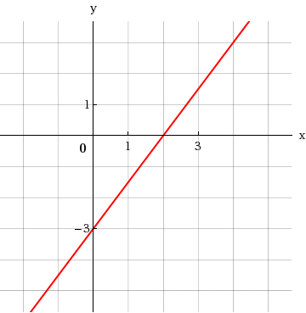

2.
[–/1 Points]DETAILSSPRECALC7 1.10.022.
MY NOTES
PRACTICE ANOTHER
Find an equation for the line whose graph is sketched.

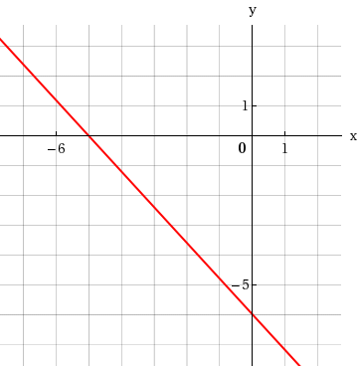

3.
[–/1 Points]DETAILSSPRECALC7 1.10.023.MI.
MY NOTES
PRACTICE ANOTHER
Find an equation of the line that satisfies the given conditions.
Slope 9; y-intercept −6

4.
[–/1 Points]DETAILSSPRECALC7 1.10.024.MI.
MY NOTES
PRACTICE ANOTHER
Find an equation of the line that satisfies the given conditions.
Slope
5
8
; y-intercept 9

5.
[–/1 Points]DETAILSSPRECALC7 1.10.025.MI.
MY NOTES
PRACTICE ANOTHER
Find an equation of the line that satisfies the given conditions.
Through (4, 1); slope 2

6.
[–/1 Points]DETAILSSPRECALC7 1.10.026.MI.
MY NOTES
PRACTICE ANOTHER
Find an equation of the line that satisfies the given conditions.
Through (−2, 7); slope −1

7.
[–/1 Points]DETAILSSPRECALC7 1.10.027.MI.
MY NOTES
PRACTICE ANOTHER
Find an equation of the line that satisfies the given conditions.
Through (3, 5); slope
2
3

8.
[–/1 Points]DETAILSSPRECALC7 1.10.028.MI.
MY NOTES
PRACTICE ANOTHER
Find an equation of the line that satisfies the given conditions.
Through (−1, −5); slope −
7
2

9.
[–/1 Points]DETAILSSPRECALC7 1.10.029.
MY NOTES
PRACTICE ANOTHER
Find an equation of the line that satisfies the given conditions.
Through (7, 3) and (6, 9)

10.
[–/1 Points]DETAILSSPRECALC7 1.10.030.MI.
MY NOTES
PRACTICE ANOTHER
Find an equation of the line that satisfies the given conditions.
Through (−1, −2) and (6, 5)

SPRECALC7 2.1.001.
MY NOTES
PRACTICE ANOTHER
If
f(x) = x³ + 1,
then give the following.
(a) the value of f at
x = −1
is
f
=
(b) the value of f at
x = 4
is
f
=
(c) the net change in the value of f between
x = −1
and
x = 4
is
f
− f (−1) =

2.
[–/2 Points]DETAILSSPRECALC7 2.1.002.
MY NOTES
PRACTICE ANOTHER
For a function f, the set of all possible inputs is called the  of f, and the set of all possible outputs is called the of f.

3.
[–/4 Points]DETAILSSPRECALC7 2.1.003.
MY NOTES
PRACTICE ANOTHER
(a) Which of the following functions have 2 in their domain? (Select all that apply.)
f(x) = x² − 3x
h(x) =
x − 4
g(x) =
x − 2
x

(b) For the functions from part (a) that do have 2 in their domain, find the value of the function at 2. (If 2 is not in the domain, enter UNDEFINED.)
f(x) = x² − 3x
g(x) =
x − 2
x

h(x) =
x − 4

4.
[–/5 Points]DETAILSSPRECALC7 2.1.004.
MY NOTES
PRACTICE ANOTHER
A function is given algebraically by the formula f(x) = (x − 6)² + 5. Complete these other ways to represent f:
(a) Verbal: "Subtract 6, then and .
(b) Numerical:
x | f(x)
0 | 41
2
4
6

5.
[–/2 Points]DETAILSSPRECALC7 2.1.005.
MY NOTES
PRACTICE ANOTHER
A function f is a rule that assigns to each element x in a set A exactly element(s) called
f(x)
in a set B. Which of the following tables defines y as a function of x?
(i) |  |  | (ii)
  x | y
  1 | 7
  2 | 3
  3 | 5
  4 | 6
  x | y
  1 | 7
  1 | 3
  2 | 5
  3 | 6
(i)(ii)

6.
[–/2 Points]DETAILSSPRECALC7 2.1.006.
MY NOTES
PRACTICE ANOTHER
Yes or No? If No, give a reason. Let f be a function.
(a) Is it possible that
f(2) = 7
and
f(3) = 7?

Yes.No. A function assigns each value of x in its domain to exactly one value of f(x). No. A function assigns each value of f(x) in its range to exactly one value of x.No. A function expecting a variable cannot be called with a constant argument.No. There is no possible function operations that would yield 7 from 3.
(b) Is it possible that
f(2) = 7
and
f(2) = 6?

Yes.No. A function assigns each value of x in its domain to exactly one value of f(x). No. A function assigns each value of f(x) in its range to exactly one value of x.No. A function expecting a variable cannot be called with a constant argument.No. There is no possible function operations that would yield 6 from 2.

7.
[–/1 Points]DETAILSSPRECALC7 2.1.007.
MY NOTES
PRACTICE ANOTHER
Express the rule in function notation. (For example, the rule "square, then subtract 5" is expressed as the function
f(x) = x² − 5.)
Multiply by 4, then subtract 8.
f(x) =

8.
[–/1 Points]DETAILSSPRECALC7 2.1.008.
MY NOTES
PRACTICE ANOTHER
Express the rule in function notation. (For example, the rule "square, then subtract 5" is expressed as the function
f(x) = x² − 5.)
Square, then add 5.
f(x) =

9.
[–/1 Points]DETAILSSPRECALC7 2.1.009.
MY NOTES
PRACTICE ANOTHER
Express the rule in function notation. (For example, the rule "square, then subtract 5" is expressed as the function
f(x) = x² − 5.)
Subtract 9, then square.
f(x) =

10.
[–/1 Points]DETAILSSPRECALC7 2.1.010.
MY NOTES
PRACTICE ANOTHER
Express the rule in function notation. (For example, the rule "square, then subtract 5" is expressed as the function
f(x) = x² − 5.)
Add 7, take the square root, then divide by 8.
f(x) =

11.
[–/1 Points]DETAILSSPRECALC7 2.1.011.
MY NOTES
PRACTICE ANOTHER
Express the function (or rule) in words.
f(x) = 2x + 9
Add 9, then square the result.Square, then add 9. Multiply by 9, then add 2.Add 9, then multiply the result by 2.Multiply by 2, then add 9.

12.
[–/1 Points]DETAILSSPRECALC7 2.1.012.
MY NOTES
PRACTICE ANOTHER
Express the function (or rule) in words.
g(x) =
x + 3
5
Square, then add 5.Divide by 5, then add 3. Add 3, then multiply by 5.Add 3, then divide by 5.Multiply by 5, then subtract 3.

13.
[–/1 Points]DETAILSSPRECALC7 2.1.013.
MY NOTES
PRACTICE ANOTHER
Express the function (or rule) in words.
h(x) = 5(x + 4)
Divide by 5, then subtract 4.Square, then add 5. Add 4, then multiply by 5.Multiply by 5, then add 4.Add 4, then divide by 5.

14.
[–/1 Points]DETAILSSPRECALC7 2.1.014.
MY NOTES
PRACTICE ANOTHER
Express the function (or rule) in words.
k(x) =
x² − 6
2
Square, then subtract 6, then divide by 2.Subtract 6, then divide by 2, then square. Square, then divide by 2, then subtract 6.Multiply by 2, then add 6, then take the square root.Divide by 2, then subtract 6, then square.

15.
[–/4 Points]DETAILSSPRECALC7 2.1.019.
MY NOTES
PRACTICE ANOTHER
Evaluate the function at the indicated values. (If an answer is undefined, enter UNDEFINED.)
f(x) = x² − 5;

f(−3), f(3), f(0), f

1
2

f(−3) | =
f(3) | =
f(0) | =
f | =
  1
  2
To graph the function f, we plot the points
x,
in a coordinate plane.
To graph
f(x) = x² − 4,
we plot the following points.
(x, x − 3)(x, x² − 4) (x, 1)(x, 2x)(x, 0)
So the point
3,
is on the graph of f. The height of the graph of f above the x-axis when
x = 3
is .
Complete the table.
x | f(x) = x² − 4 | (x, y)
−2
−1
0
1
2
Sketch a graph of f.
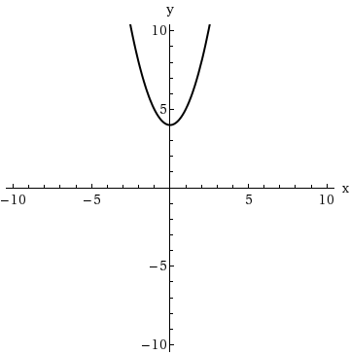 | 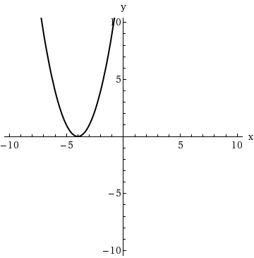
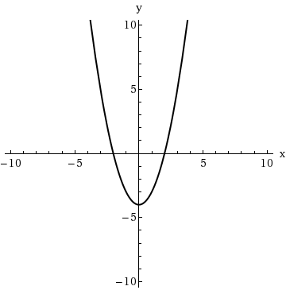 | 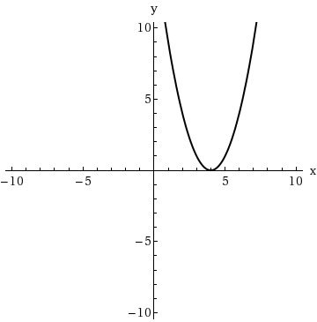

2.
[–/1 Points]DETAILSSPRECALC7 2.2.002.
MY NOTES
PRACTICE ANOTHER
If
f(4) = 14,
then the point
4,
is on the graph of f.

3.
[–/1 Points]DETAILSSPRECALC7 2.2.003.
MY NOTES
PRACTICE ANOTHER
If the point (5, 4) is on the graph of f, then f(5) = .

4.
[–/4 Points]DETAILSSPRECALC7 2.2.004.
MY NOTES
Match the function with its graph.
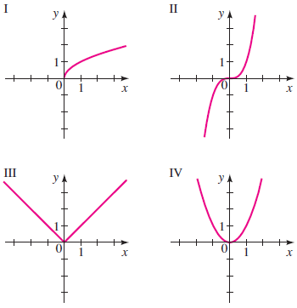

(a) f(x) = x²
(b) f(x) = x³
(c) f(x) =
x

(d) f(x) = |x|

5.
[–/8 Points]DETAILSSPRECALC7 2.2.005.
MY NOTES
PRACTICE ANOTHER
Sketch the graph of the function by first making a table of values. (If an answer is undefined, enter UNDEFINED.)
f(x) = x + 2
x | f(x) = x + 2
−6
−4
−2
0
2
4
6
Sketch the graph.
Sketch the graph of the function by first making a table of values. (If an answer is undefined, enter UNDEFINED.)
f(x) = 2 − 3x
x | f(x) = 2 − 3x
−2
−1
0
1
2
3
4
Sketch the graph.

Sketch the graph of the function by first making a table of values.
f(x) = −x + 3, −3 ≤ x ≤ 3
x | f(x) = −x + 3
−3
−2
0
1
2
3
Sketch the graph.

Sketch the graph of the function by first making a table of values.
f(x) =
x − 2
2
,
0 ≤ x ≤ 5
x | f(x) =
  x − 2
  2
0
1
2
3
4
5
Sketch the graph.

Sketch the graph of the function by first making a table of values.
f(x) = −x²
x | f(x) = −x²
0
±4
±3
±2
±1
Sketch the graph.
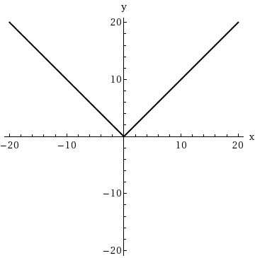 | 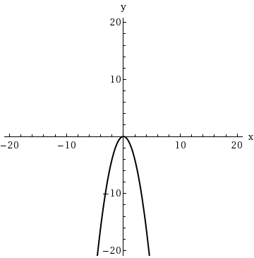
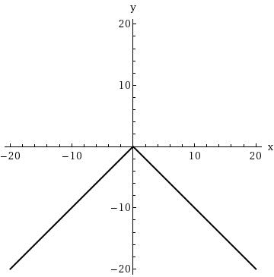 | 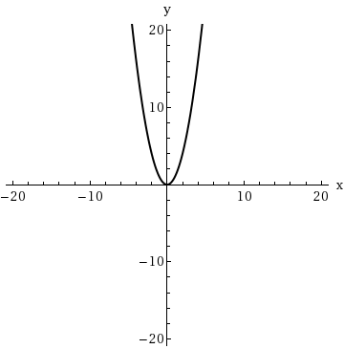

10.
[–/7 Points]DETAILSSPRECALC7 2.2.010.MI.
MY NOTES
PRACTICE ANOTHER
Sketch the graph of the function by first making a table of values.
f(x) = x² − 4
x | f(x) = x² − 4
±5
±4
±3
±2
±1
0
Sketch the graph.
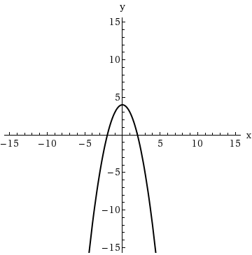 | 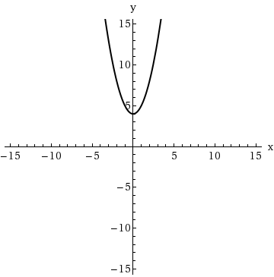
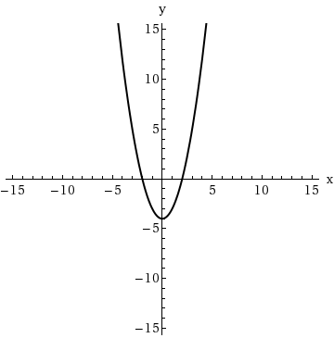 | 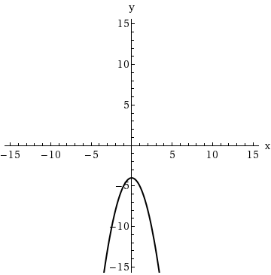

11.
[–/8 Points]DETAILSSPRECALC7 2.2.011.
MY NOTES
PRACTICE ANOTHER
Sketch the graph of the function by first making a table of values. (If an answer is undefined, enter UNDEFINED.)
g(x) = −(x + 5)²
x | g(x) = −(x + 5)²
−5
−3
−2
−1
0
1
3
Sketch the graph.
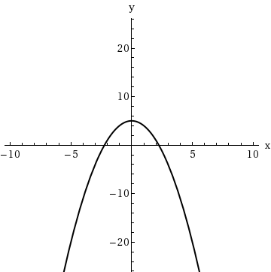 | 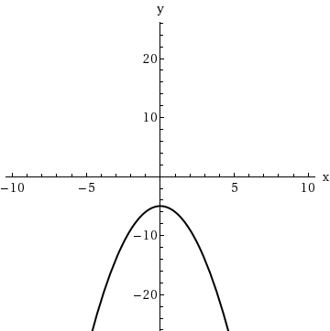
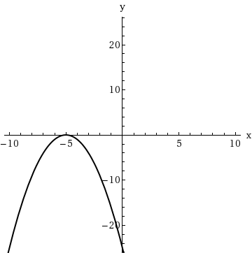 | 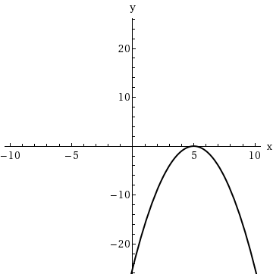

12.
[–/8 Points]DETAILSSPRECALC7 2.2.012.
MY NOTES
PRACTICE ANOTHER
Sketch the graph of the function by first making a table of values. (If an answer is undefined, enter UNDEFINED.)
g(x) = x² + 4x + 4
x | g(x) = x² + 4x + 4
−3
−2
−1
0
1
2
3
Sketch the graph.
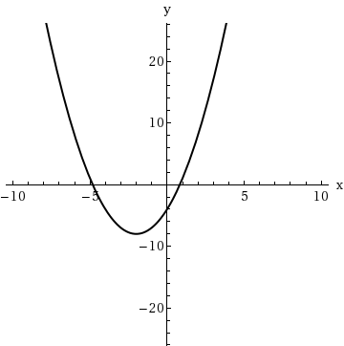 | 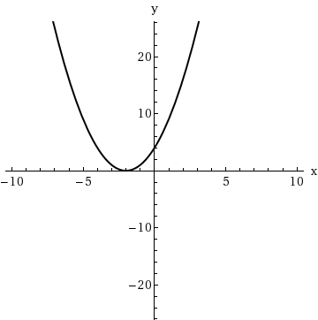
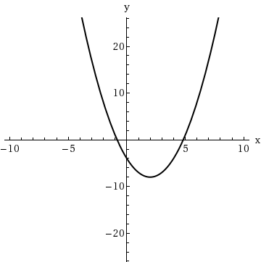 | 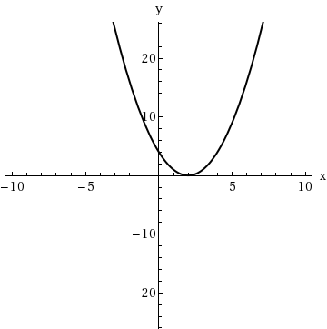

13.
[–/8 Points]DETAILSSPRECALC7 2.2.013.
MY NOTES
PRACTICE ANOTHER
Sketch the graph of the function by first making a table of values. (If an answer is undefined, enter UNDEFINED.)
r(x) = 4x⁴
x | r(x) = 4x⁴
−3
−2
−1
0
1
2
3
Sketch the graph.
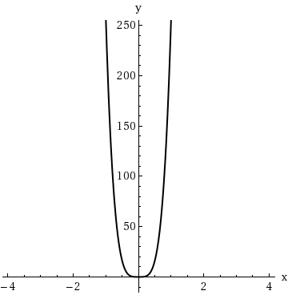 | 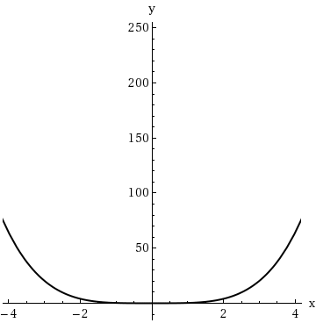
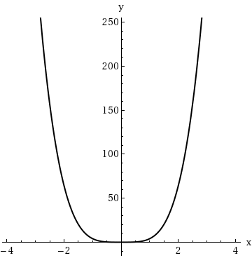 | 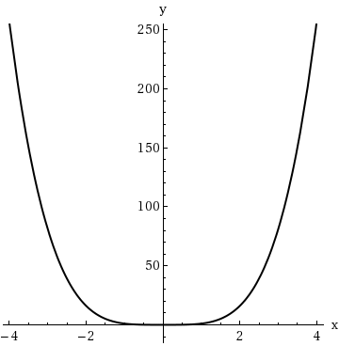

14.
[–/8 Points]DETAILSSPRECALC7 2.2.014.
MY NOTES
PRACTICE ANOTHER
Sketch the graph of the function by first making a table of values. (If an answer is undefined, enter UNDEFINED.)
r(x) = 2 − x⁴
x | r(x) = 2 − x⁴
−3
−2
−1
0
1
2
3
Sketch the graph.
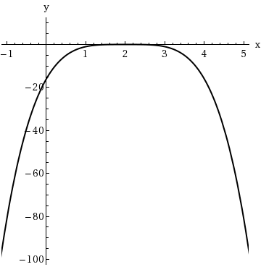 | 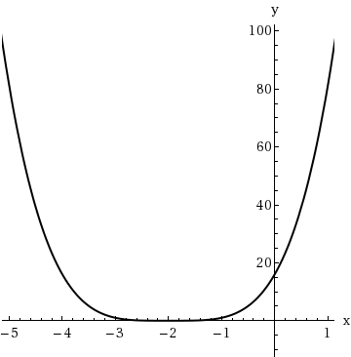
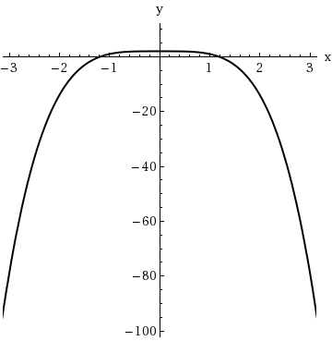 | 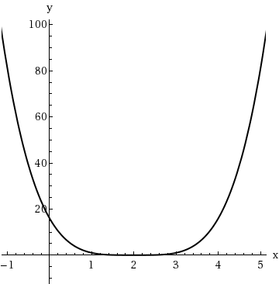

15.
[–/8 Points]DETAILSSPRECALC7 2.2.015.
MY NOTES
PRACTICE ANOTHER
Sketch the graph of the function by first making a table of values.
g(x) = x³ − 4
x | g(x) = x³ − 4
−3
−2
−1
0
1
2
3
Sketch the graph.
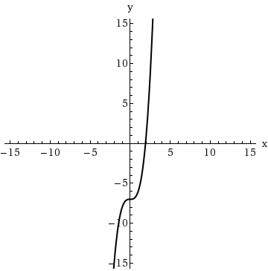 | 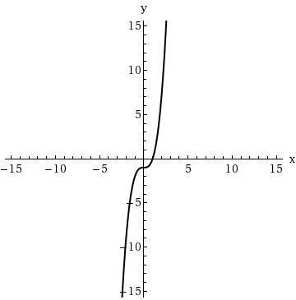
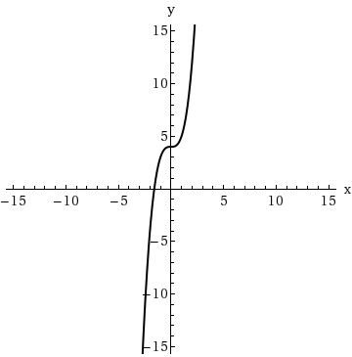 | 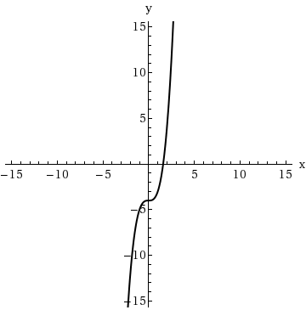

16.
[–/8 Points]DETAILSSPRECALC7 2.2.016.
MY NOTES
PRACTICE ANOTHER
Sketch the graph of the function by first making a table of values. (If an answer is undefined, enter UNDEFINED.)
g(x) = (x − 2)³
x | g(x) = (x − 2)³
−3
−2
−1
0
1
2
3
Sketch the graph.
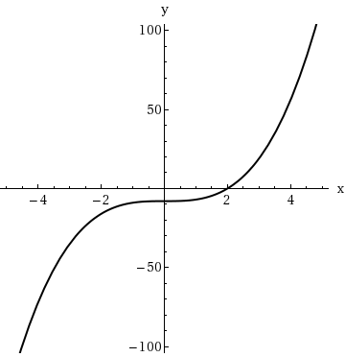 | 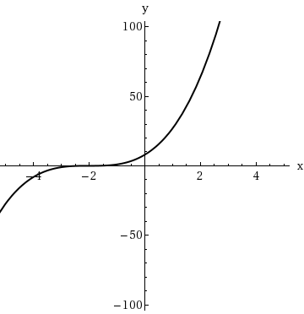
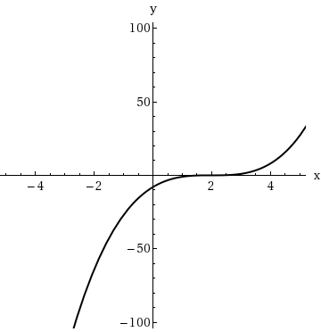 | 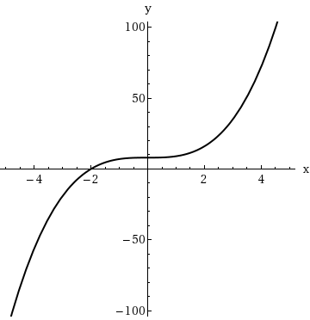

17.
[–/8 Points]DETAILSSPRECALC7 2.2.017.
MY NOTES
Sketch the graph of the function by first making a table of values. (If an answer is undefined, enter UNDEFINED.)
k(x) =
3 |  | −x
 | x |  | k(x) =
  3 |  | −x
 | −27
 | −8
 | −1
 | 0
 | 1
 | 8
 | 27
Sketch the graph.
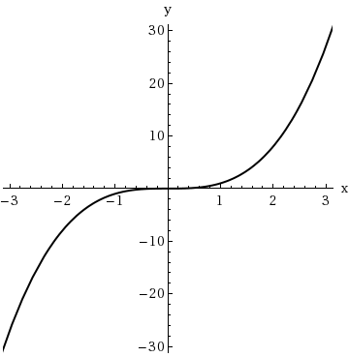 | 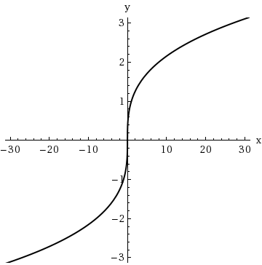
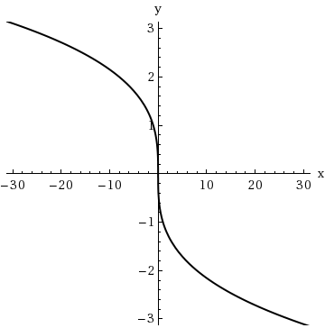 | 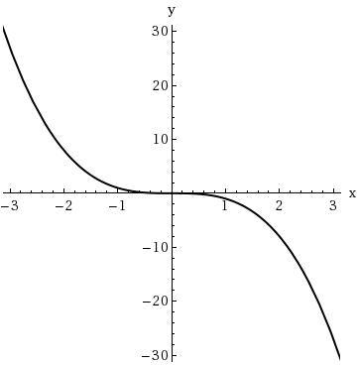

18.
[–/8 Points]DETAILSSPRECALC7 2.2.018.
MY NOTES
Sketch the graph of the function by first making a table of values. (If an answer is undefined, enter UNDEFINED.)
k(x) = −
3 |  | x
 | x |  | k(x) = −
  3 |  | x
 | −27
 | −8
 | −1
 | 0
 | 1
 | 8
 | 27
Sketch the graph.

19.
[–/7 Points]DETAILSSPRECALC7 2.2.019.
MY NOTES
PRACTICE ANOTHER
Sketch the graph of the function by first making a table of values.
f(x) = 6 +
 | x
 |  | x | f(x) = 6 +
  x
 |  | 0
 |  | 1
 |  | 4
 |  | 9
 |  | 16
 |  | 25
Sketch the graph.
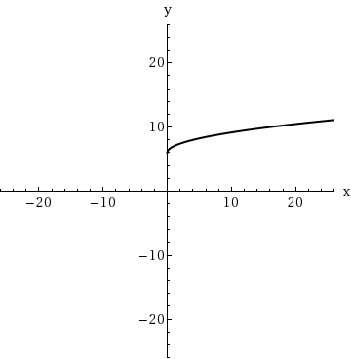 | 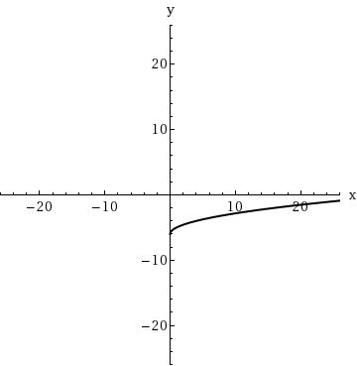
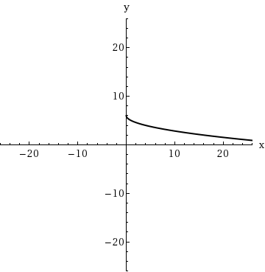 | 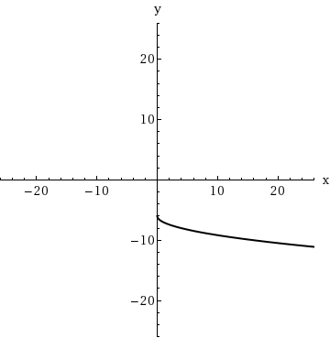

20.
[–/8 Points]DETAILSSPRECALC7 2.2.020.
MY NOTES
PRACTICE ANOTHER
Sketch the graph of the function by first making a table of values. (If an answer is undefined, enter UNDEFINED.)
f(x) =
 | x − 4
x |  | f(x) =
  x − 4
4
5
8
13
20
29
40
Sketch the graph.
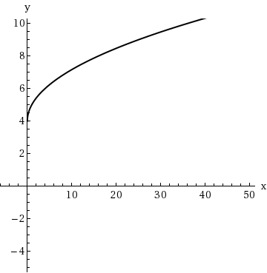 | 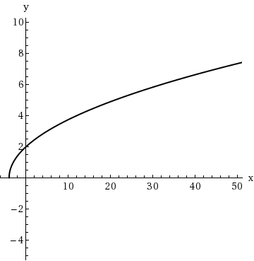
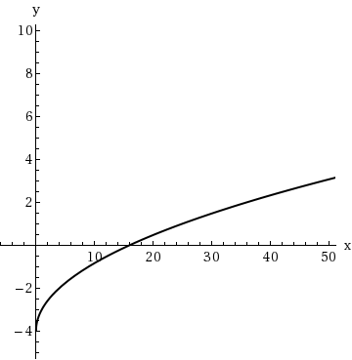 | 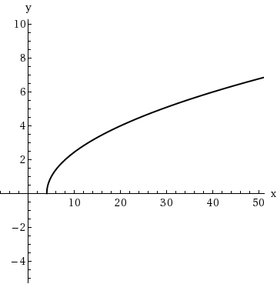
PRACTICE ANOTHER
If you travel 200 miles in ten hours, then your average speed for the trip is
average speed =
200
=
mi/h

2.
[–/2 Points]DETAILSSPRECALC7 2.4.002.
MY NOTES
PRACTICE ANOTHER
The average rate of change of a function f between
x = d
and
x = a
is
average rate of change =
f

− f

a − d

3.
[–/2 Points]DETAILSSPRECALC7 2.4.003.
MY NOTES
PRACTICE ANOTHER
The average rate of change of a function
f(x) = x²
between
x = 1
and
x = 8
is
average rate of change =
8 − 1
=
.

4.
[–/2 Points]DETAILSSPRECALC7 2.4.004.
MY NOTES
PRACTICE ANOTHER
(a) The average rate of change of a function f between x = a and x = b is the slope of the line between (a, f(a)) and (b, f(b)).
(b) The average rate of change of the linear function f(x) = 6x + 6 between any two points is .

5.
[–/4 Points]DETAILSSPRECALC7 2.4.005.
MY NOTES
Yes or No?
(a) Is the average rate of change of a function between
x = a
and
x = b
the slope of the secant line through
(a, f(a))
and
(b, f(b))?

YesNo
If No, give a reason. (If Yes, enter Yes.)
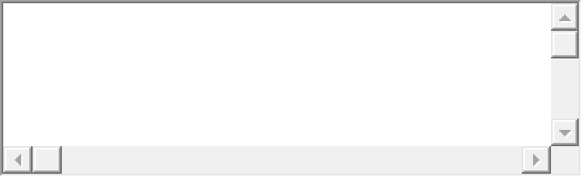
This answer has not been graded yet.
(b) Is the average rate of change of a linear function the same for all intervals?
YesNo
If No, give a reason. (If Yes, enter Yes.)
This answer has not been graded yet.

6.
[–/4 Points]DETAILSSPRECALC7 2.4.006.
MY NOTES
Yes or No?
(a) Can the average rate of change of an increasing function ever be negative?
YesNo
If No, give a reason. (If Yes, enter Yes.)
This answer has not been graded yet.
(b) If the average rate of change of a function between
x = a
and
x = b
is negative, then is the function necessarily decreasing on the interval
(a, b)?

YesNo
If No, give a reason. (If Yes, enter Yes.)
This answer has not been graded yet.

7.
[–/2 Points]DETAILSSPRECALC7 2.4.007.MI.
MY NOTES
PRACTICE ANOTHER
The graph of a function is given.
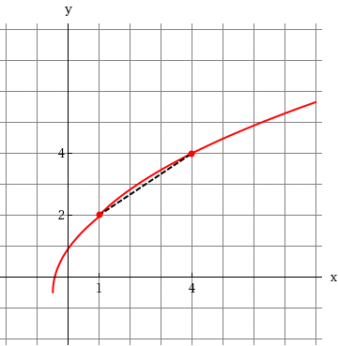
(a) Determine the net change between the indicated points on the graph.
(b) Determine the average rate of change between the indicated points on the graph.

8.
[–/2 Points]DETAILSSPRECALC7 2.4.009.
MY NOTES
PRACTICE ANOTHER
The graph of a function is given.
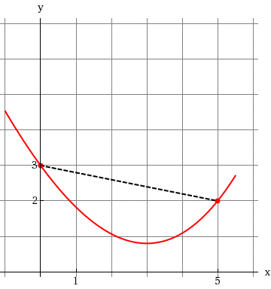
(a) Determine the net change between the indicated points on the graph.
(b) Determine the average rate of change between the indicated points on the graph.

9.
[–/2 Points]DETAILSSPRECALC7 2.4.010.MI.
MY NOTES
PRACTICE ANOTHER
The graph of a function is given.
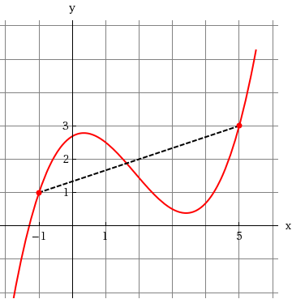
(a) Determine the net change between the indicated points on the graph.
(b) Determine the average rate of change between the indicated points on the graph.

10.
[–/2 Points]DETAILSSPRECALC7 2.4.011.MI.
MY NOTES
PRACTICE ANOTHER
A function is given.
f(x) = 7x − 6; x = 2, x = 3
(a) Determine the net change between the given values of the variable.

(b) Determine the average rate of change between the given values of the variable.

11.
[–/2 Points]DETAILSSPRECALC7 2.4.012.
MY NOTES
PRACTICE ANOTHER
A function is given.
r(t) = 2 −
1
2
t; t = 2, t = 4
(a) Determine the net change between the given values of the variable.

(b) Determine the average rate of change between the given values of the variable.

12.
[–/2 Points]DETAILSSPRECALC7 2.4.013.
MY NOTES
PRACTICE ANOTHER
A function is given.
h(t) = −t +
4
3
; t = −4, t = 1
(a) Determine the net change between the given values of the variable.

(b) Determine the average rate of change between the given values of the variable.

13.
[–/2 Points]DETAILSSPRECALC7 2.4.015.
MY NOTES
PRACTICE ANOTHER
A function is given.
h(t) = 2t² − t; t = 2, t = 3
(a) Determine the net change between the given values of the variable.

(b) Determine the average rate of change between the given values of the variable.

14.
[–/2 Points]DETAILSSPRECALC7 2.4.018.
MY NOTES
PRACTICE ANOTHER
A function is given.
g(t) = t⁴ − t³ + t²; t = −4, t = 4
(a) Determine the net change between the given values of the variable.

(b) Determine the average rate of change between the given values of the variable.

15.
[–/2 Points]DETAILSSPRECALC7 2.4.023.
MY NOTES
PRACTICE ANOTHER
A function is given.
f(t) =
6
t
; t = a, t = a + h
(a) Determine the net change between the given values of the variable.

(b) Determine the average rate of change between the given values of the variable.

MY NOTES
If a function f is an odd function, then what type of symmetry does the graph of f have?
The function f has symmetry with respect to the origin.The function f has symmetry with respect to the x-axis. The function f has symmetry with respect to the y-axis.

2.
[–/2 Points]DETAILSSPRECALC7 2.6.007.
MY NOTES
PRACTICE ANOTHER
Suppose the graph of f is given. Describe how the graph of each function can be obtained from the graph of f.
(a)
f(x) − 7

shift left 7 unitsshift right 7 units shift up 7 unitsshift down 7 unitsstretch vertically by a factor of 7
(b)
f(x − 2)

shift left 2 unitsshift right 2 units shift up 2 unitsshift down 2 unitsstretch vertically by a factor of 2

3.
[–/2 Points]DETAILSSPRECALC7 2.6.008.
MY NOTES
PRACTICE ANOTHER
Suppose the graph of f is given. Describe how the graph of each function can be obtained from the graph of f.
(a)
f(x + 5)

shift left 5 unitsshift right 5 units shift up 5 unitsshift down 5 unitsstretch vertically by a factor of 5
(b)
f(x) + 6

shift left 6 unitsshift right 6 units shift up 6 unitsshift down 6 unitsstretch vertically by a factor of 6

4.
[–/2 Points]DETAILSSPRECALC7 2.6.009.
MY NOTES
PRACTICE ANOTHER
Suppose the graph of f is given. Describe how the graph of each function can be obtained from the graph of f.
(a)
f(−x)

reflect about the y-axisreflect about the x-axis reflect about the originshift to the left by 1 unitshift to the right by 1 unit
(b)
5f(x)

reflect about the y-axisreflect about the x-axis reflect about the originshrink vertically by 5stretch vertically by 5

5.
[–/2 Points]DETAILSSPRECALC7 2.6.010.
MY NOTES
PRACTICE ANOTHER
Suppose the graph of f is given. Describe how the graph of each function can be obtained from the graph of f.
(a)
−f(x)

reflect about the y-axisreflect about the x-axis reflect about the originshift to the left by 1 unitshift to the right by 1 unit
(b)
1
6
f(x)

reflect about the y-axisreflect about the x-axis reflect about the originshrink vertically by 1/6stretch vertically by 1/6

6.
[–/2 Points]DETAILSSPRECALC7 2.6.011.
MY NOTES
PRACTICE ANOTHER
Suppose the graph of f is given. Describe how the graph of each function can be obtained from the graph of f.
(a)
y = f(x − 1) + 2

shift 2 units to the right and 1 unit upwardshift 1 unit to the left and 2 units downward shift 1 unit to the right and 2 units upwardreflect about the x-axis, then shift 2 units upwardshift 2 units to the left and 1 unit downward
(b)
y = f(x + 9) − 1

shift 1 unit to the left and 9 units downwardshift 1 unit to the right and 9 units upward reflect about the y-axis, then shift 9 units to the leftshift 9 units to the left and 1 unit downwardshift 9 units to the right and 1 unit upward

7.
[–/2 Points]DETAILSSPRECALC7 2.6.012.
MY NOTES
PRACTICE ANOTHER
Suppose the graph of f is given. Describe how the graph of each function can be obtained from the graph of f.
(a)
y = f(x + 6) + 2

shift 2 units to the right and 6 units downwardshift 6 units to the left and 2 units downward shift 6 units to the left and 2 units upwardshift 2 units to the right and 6 units upwardshift 6 units to the right and 2 units upward
(b)
y = f(x − 5) − 3

shift 5 units to the right and 3 units downwardshift 5 units to the left and 3 units downward shift 3 units to the left and 5 units upwardshift 3 units to the right and 5 units downwardshift 5 units to the right and 3 units upward

8.
[–/2 Points]DETAILSSPRECALC7 2.6.013.
MY NOTES
PRACTICE ANOTHER
Suppose the graph of f is given. Describe how the graph of each function can be obtained from the graph of f.
(a)
y = −f(x) + 5

reflect about the x-axis, then shift down 5 unitsreflect about the y-axis, then shift up 5 units reflect about the y-axis, then shift left 5 unitsreflect about the y-axis, then shift down 5 unitsreflect about the x-axis, then shift up 5 units
(b)
y = 6f(x) − 5

stretch vertically by a factor of 6, then shift up 5 unitsstretch vertically by a factor of 6, then shift down 5 units shift down 5 units, then stretch vertically by a factor of 6stretch vertically by a factor of 5, then shift down 6 unitsshrink vertically by a factor of 6, then shift down 5 units

9.
[–/2 Points]DETAILSSPRECALC7 2.6.015.
MY NOTES
PRACTICE ANOTHER
Suppose the graph of f is given. Describe how the graph of each function can be obtained from the graph of f.
(a)
4f(x + 7) − 1

shift 7 units to the left, stretch vertically by 4, then shift upward 1 unitshift 7 units to the left, stretch vertically by 4, then shift downward 1 unit shift 7 units to the left, shrink vertically by 4, then shift downward 1 unitshift 7 units to the right, stretch vertically by 4, then shift downward 1 unitshift 7 units to the right, shrink vertically by 4, then shift downward 1 unit
(b)
1
4
f(x − 5) + 7

shift 5 units to the left, stretch vertically by 1/4, then shift upward 7 unitsshift 5 units to the right, stretch vertically by 1/4, then shift upward 7 units shift 5 units to the right, shrink vertically by 1/4, then shift downward 7 unitsshift 5 units to the right, shrink vertically by 1/4, then shift upward 7 unitsshift 5 units to the left, shrink vertically by 1/4, then shift upward 7 units

10.
[–/2 Points]DETAILSSPRECALC7 2.6.018.
MY NOTES
PRACTICE ANOTHER
Suppose the graph of f is given. Describe how the graph of each function can be obtained from the graph of f.
(a)
y = f(7x) − 5

shrink vertically by a factor of
1
7
,
then shift up 5 unitsshrink horizontally by a factor of
1
7
,
then shift right 5 units stretch vertically by a factor of 7, then shift up 5 unitsshrink horizontally by a factor of
1
7
,
then shift down 5 unitsstretch horizontally by a factor of 7, then shift down 5 units
(b)
y = 7f

1
7
x

stretch horizontally by a factor of 7, then stretch vertically by a factor of 7There is no change. stretch horizontally by a factor of 7, then shrink vertically by a factor of
1
7
shrink horizontally by a factor of
1
7
,
then shrink vertically by a factor of
1
7
shrink horizontally by a factor of
1
7
,
then stretch vertically by a factor of 7

